**TITLE OF PROJECT**

SEGI CAR PARKING SYSTEM

**NAME OF STUDENT**

**MUHAMMAD ANNAS MOIZ**

**A project report submitted in partial fulfillment**

**of the requirements for the award of**

**Bachelor of Information Technology (Hons)**

**BIT (BSD)**

**Faculty of Engineering, Built Environment, and Information Technology**

**SEGi University**

**MAY 2023**

**Month year**

**DECLARATION**

I hereby declare that this project report is based on my original work except for citations and quotations which have been duly acknowledge. I also declare that it has not been previously and concurrently submitted for any other degree or award at SEGI UNIVERSITY or other institutions.

Signature: MA

Name: MUHAMMAD ANNAS MOIZ

ID No: SUKD1902235

Date: 15/05/2023

APPROVAL FOR SUBMISSION

I certify that this project report entitled “CAR PARKING SYSTEM” was prepared by **MUHAMMAD ANNAS MOIZ** has met the required standard for submission in partial fulfilment of the requirements for the award of Bachelor of Information Technology (Hons) at SEGi University.

Approved by:

Signature: ______________________

Supervisor: ______________________

Date: ______________________

The copyright of this report belongs to the author under the terms of the copyright Act 1987 as qualified by Intellectual Property Policy of SEGi University. Due acknowledgement shall always be made of the use of any material contained in or derived from this report.

© Year, Name of candidate. All rights reserved

ACKNOWLEDGEMENT

In preparing this final year project, I was in contact with many people, researchers, academicians, and practitioners. They have contributed towards my understanding and thoughts. In particular, I wish to express my sincere appreciation to my main thesis supervisor, Mr. Mohd Fuad bin abdullah

possible to list all of them in this limited space. I am grateful to all my family member. All my teachers and all my friends who have supported me and have guided me throughout the years and made me credible enough to achieve this position.

ABSTRACT

The purpose of this project is to research, study, analyse and provide everything in order to develop the desired CAR PARKING SYSTEM, this report will briefly explain the foundation of the SYSTEM while performing research based on similar systems, analyses and brainstorming. The report consists of 6 chapters in total. Each chapter with different categories and components leading up to the implementation then testing and then finally the results from which we can elaborate problems, fix bus and update, this report is environmentally friendly and progressive, it falls in the basic category of research website, however many other segmentation are explained in the report with examples, tables, figures, which all help the user get a better understanding,

TABLE OF CONTENTS

|  |  |  |
| --- | --- | --- |
|  | TITLE | PAGE |

APPROVAL FOR SUBMISSION iii

ACKNOWLEDGEMENT v

ABSTRACT vi

TABLE OF CONTENTS vii

LIST OF TABLES x

LIST OF FIGURES xi

LIST OF APPENDICES xii

CHAPTER 1 INTRODUCTION 1

1.1 Introduction 1

1.2 Problem Background 1

1.3 Problem Solution 2

1.4 Aims and Objectives 3

1.4.1 Project Aim 4

1.4.2 Project Objectives 4

1.5 Project Scope 5

1.6 Significance of the Project 6

1.7 Organization of the Report 6

CHAPTER 2 LITERATURE REVIEW 9

2.1 Introduction 9

2.2 Your topic/area (distinction from other similar systems) 9

2.2.1 Further discussion on the topic/area(PREVIOUS FYP) 9

2.2.2 Further discussion on the topic/area(invoice generator) 10

2.2.3 further discussion on the topic/area (CUSTOMER INTERFACE) 10

2.2.4 further discussion on the topic/area (QR scan using goggle forms) 10

2.3 Development Platform 11

2.3.1 Hardware 11

2.3.2 Software 11

2.3.3 Justification for Selection of draw.io 11

2.3.4 Justification for selection of visual studios (c#) 12

2.3.5 Justification for using Microsoft SQL server 12

2.4 Chapter Summary 12

CHAPTER 3 METHODOLOGY, ANALYSIS AND DESIGN 13

3.1 Introduction 13

3.1.1 Proposed Methodology 13

3.1.1.1 Methodology Activities 15

3.2 System Analysis 19

3.2.1 Functional and Non-Functional Requirements 20

3.2.2 Use Case Diagram 21

3.2.3 Use Case Descriptions 22

3.2.4 22

3.2.5 23

3.2.6 24

3.2.7 24

3.2.8 25

3.2.9 25

3.2.10 26

3.2.11 26

3.2.12 27

3.3 System Design 28

3.3.1 Sequence Diagram 29

3.3.2 Class Diagram 30

Figure 3.4 30

3.3.3 Data Dictionary (table 3.10) 31

3.3.4 TEST PLAN 32

Table 3.11 33

3.4 Chapter Summary 33

CHAPTER 4 IMPLEMENTATION 35

4.0 Introduction 35

4.1 Development Environment 36

4.2 System Development 38

4.2.1 Database Development 42

4.2.2 Client/customer Interface Development 43

4.2.3 Programming Code Development 49

4.3 Database implementation 69

4.4 Test Results 73

4.5 Chapter Summary 87

CHAPTER 5 RESULTS AND DISCUSSION 89

5.0 Introduction 89

5.1 Results of the Project 89

5.2 Evaluation of the system 91

5.3 Evaluation of the development Process 91

5.4 Chapter Summary 91

CHAPTER 6 CONCLUSION AND RECOMMENDATIONS 93

6.0 Introduction 93

6.1 Project Result and Achievement 93

6.2 Advantages of the Application/Website/System 93

6.3 Recommendation for Future Enhancement 94

6.4 Conclusion 94

REFERENCES 95

**https://revisesociology.com/2017/11/26/the-steps-of-quantitative-research/**. 95

LIST OF TABLES

|  |  |  |
| --- | --- | --- |
| TABLE NO. | TITLE | PAGE |

Table 3.0 uc1 22

Table 3.1 uc2 22

Table 3.2 uc3 23

Table 3.3 uc4 24

Table 3.4 uc5 24

Table 3.5 uc6 25

Table 3.6 uc7 25

Table 3.7 uc8 26

Table 3.8 uc9 26

Table 3.9 uc10 27

Table 3.10 Data dictionary 31

Table 3.11 test plan 32-33

Table 3.12 test result 73-75

LIST OF FIGURES

|  |  |  |
| --- | --- | --- |
| FIGURE NO. | TITLE | PAGE |

Figure 3.0 quantitve research diagram 14

Figure 3.1 UC diagram 21

Figure 3.2 system design 28

figure 3.3 sequince diagram 29

figure 3.4 class diagram 30

figure 4.1 to figure 4.83 system design images/code images/test images 36-86

LIST OF APPENDICES

|  |  |  |
| --- | --- | --- |
| APPENDIX | TITLE | PAGE |

Appendix A Requirement Specification 27

Appendix B Project Proposal Form 28

Appendix C Progress Log Sheets 29

# INTRODUCTION

## Introduction

This is a Car parking system report, chapter 1, in which the basic ideas and analogy of the plan will be described and explained for the reader, the complex attributes regarding the initial development of this car parking system will be explained briefly.

This car parking system is developed using multiple applications and forms. However, in this chapter the basic development phase will be explained such as:- problem background, aim and objectives etc for the user to get the basic idea of the system.

## Problem Background

During this era of such fast development in infrastructure around the whole world is in fact astonishing. Lately there are a lot of buildings, offices, Malls, schools etc which all require a parking lot for their visiting or occupying customers, knowing this there is a lot of earning potential that require a parking system which can earn, sustain, and maintain there organization by the support of this system, so in short there is a huge demand for a well coded parking system.

The venture selected for the car parking system is SEGI University. This university has a high range of parking lots available both outside and inside. In addition to that the inside parking lot was recently renovated and upgraded. In regards for providing better education for the students a university requires expenditures, following up this university has potential to charge money for the newly renovated inside parking lot, in order for visitors to park. This lacks a car parking system.

Most of the car parking systems are alike and during this era of technology, a lot of advanced system have been created, however they do lack customer friendly functions and attributes, such as QR scanning slot assignment and slot selection by the customer influenced by an interface guide. These all attributes fall into place for user friendly. However regardless of the technologies and advancement, an organization still requires a human endeavor towards handling the system.

## Problem Solution

The SEGI car parking system is a well developed hybrid parking system which requires a data clerk, and is consisted of customer self log in as well, the QR scan system allows the customer to scan using a phone where they can log in their details, which can be verified by the clerk using the google forms. The customer can select the slots they want to park in and view which slots are available by viewing the customer interface data where the customer scanned form. The slot selection I then directed towards the clerk to manage and update the occupancy/vacancy accordingly, however the clerk first verifies the customer plates The customer can also log in manually with the help of the clerk if they choose not to self sign in

From a business approach, The amount for one hour of parking can be set to 2 RM per hour, where partnership can earn 50 sen on the RM. Now lets ‘assume’ the university has a traffic of 100 cars every day for inside parking, and each car parks for an hour; then it would mean 200rm per day, 6,000rm a month and 73,000 rm per year. This will provide the university with a passive income and a stable cash flow for the revenue that university generates. Not only that but university will be able to boost publicity and represent the co operation between student and university in return marketing the university for better student correspondence and possibly increase the number f student applying.

. This car parking system is flexible and can fit into and venture and For almost any kind of land and acts as a great asset to the organization, this includes, schools, mall centers, colleges, offices, apartments, airport, stations, hotels, compounds, government offices and also plain old parking lots.

These places all have the potential to earn from a parking system as well. As the parking system will earn a set amount of money from every single car entering the the said place of organization. It can be enlisted to take form of any kind of parking and the development can be updated easily by the admin/clerk. So the flexibility of the system ensures that it can work with any kind of business.

## Aims and Objectives

The system aim and objectives depend on the client and the venture it is being used for. However general aim and objectives for the SEGI car parking system are stated as followed onto next sub-context

.

### Project Aim

The aim of the project is to provide a customer friendly well manageable and flexible car parking system to the desired client according to their specification. In this case (segi UNIVERSITY). While ensuring quality and consistency without the worry of error. This system is aimed to manage the database of the customers and keeps track of the cars entering and leaving.

### Project Objectives

The objectives of the project are as follows:

1. To provide a well briefed report of every arrival/departure/slots selection/invoice and customer data accessible to the clerk, admin and university via system grid view.
2. To conduct literature review on the development of the system and progress and how it relates to the customer base (**segi university**).
3. To capture all requirements needed for the development of this car parking system
4. To design the framework and forms and diagrams for the guidance of the project development.
5. To implement on developing customer interface which allows the user to view available slots.
6. To develop a QR scan for the customer to self log in using link google forms.
7. To manage the verification of the customer details.

## Project Scope

The project falls in the categories of design, system development, DBMS, directory, and consists of three parts stated below: -

**System:**

* provides real time data information for the customer and admin
* Uses manual and automated clerk assistance
* allows the user to sign in using google form via QR code.
* Allows the user to see the available slots in the parking lot to choose from in customer interface.
* Allows the clerk to log in arrival
* Allows the clerk to log in the departure
* Allows the clerk to view the slots available.
* Allows the clerk to generate the customer invoice and bill.
* Allows the clerk to print out data collected in the database.

**Admin:**

* Can register
* Can login
* Can add/delete/edit/manage information
* Can manage slot occupancy/vacancy.
* Can alter design
* Can access complete report
* Can print out report

**Customer:**

* Can check in using QR
* Can view slots available
* Customer can update google forms information
* Can report problems.

## Significance of the Project

The significance of the project is quite high as mentioned previously that the rate of development of this world’s infrastructure and development, the car parking system is in high demand and is required in almost every parking lot in order to preserve and account the usage of the premises.

This system provides benefits to all kinds of business’s and helps provide jobs too if developed for according to a bigger venture. The slot selecting function and self QR log in makes the system stand out and gives it an edge against any similar car parking system.

## Organization of the Report

Chapter 1: Introduction

In this chapter reader will get background of the project, problem statement with the problem solution provided according to the problem, introduction, and complete basic analysis of the project

Chapter 2: Literature Review

In this chapter reader will get analysis of comparison is conducted with brief outcome expectations, all is formed in a literature review

Chapter 3: Methodology

In this section the project provides with the methodologies being used the design of the websites explaining with lot of different diagrams for user easement and acknowledgment.

Chapter 4: Implementation

In this section implementation will begin and development of the project is started. With coding, website details and entities explained

Chapter 5: Results & Discussion

In this section test are run and errors and bugs are pointed out in order to upgrade/update according to the bugs and errors.

Chapter 6: Conclusion

In this section will will be explained the progress and maintenance the system and the conclusion of all of the project.

# LITERATURE REVIEW

## Introduction

In this section of the project, review of the research, comparison and analysis are conducted with the **similar** system to this car parking system project which will give out the results of solution and further progress, details of the platform and its methodology With examples and brief details in the form of literature review.

## Your topic/area (distinction from other similar systems)

well obviously due to such high demand there are other similar system available however the distinction from others stand out as flexibility of choice, as the system can be automated for a larger number of scale operation where as a simple parking lot can be attuned with the help of a clerk, this choice of manual and automated work is what sets this system apart from the others. As well as multiple functions of this system that stand out from any other car parking system, such as, slot selection, QR scan, slow view/slot management, and data verification.

### Further discussion on the topic/area(PREVIOUS FYP)

This is second attempt on the FYP project, the previous one consisted of a marine conservation website, however it was determined to be a failure afterwards, following up on that this semester the new project took place in motion; development of car parking system for segi University.

### Further discussion on the topic/area(invoice generator)

Most system do not have the complete capability to print out efficient invoice this system is designed to check the reserved bill and the print out the invoice with the complete data of information, now this can be done by the customer themselves as they have the option for self check in and check out. This is another grave point of differentiation and distinction from other said systems available. All other system lack the complete segmentation not to mention the key importance of real time data which can provide a lot more benefits to day-day business assessments. This system can equip all the necessary features provided above with

### further discussion on the topic/area (CUSTOMER INTERFACE)

The customer interface is designed in a way to show real time availability o the slots in the form of occupied(red) and vacant(lime green) which is updated by the clerk as soon as customer has selected a designated place. this allows the user to map through the parking lot and park directly o the selected slot without wasting any time , without the hassle of finding a vacant slot or worrying about the traffic. This is a major function that makes the system unique.

### further discussion on the topic/area (QR scan using goggle forms)

Customer can log in by scanning the qr code provided on the customer interface with the sot availability after scanning the LINK is sent to google forms where the customer keys in the following data:

1. Driver name
2. Email address
3. Car no
4. Make and model of car.
5. Arrival date and time
6. Parked time (duration) ((update able))
7. Departure date and time
8. Slot number selection.

Amount can be paid via cash by receiving the invoice or a bank link address to pay online also available to QR pay. These functions provide customer usability and ensures a pleasant time without much hassle

Respondents/customers will be required to sing into google, this ensures only verified emails shall be used. Evidence provided in chapter 5.

## Development Platform

SYSTEM DEVELOPMENT.

### Hardware

* ACER swift 3
* TIMES WIFI 500MBPS

### Software

Windows 10

Intel i3

Norton anti-virus

Draw.io (design development)

Visual studios (c sharp)

Microsoft SQL server management (DBMS)

### Justification for Selection of draw.io

This application is really user friendly and was a great platform to map out the basic diagrams and design for the system such as flowchart, models and such which was needed quite accurately for this project system.

### Justification for selection of visual studios (c#)

I myself am really comfortable and experienced with this software, and for me it was the perfect platform to develop this system on. It is really user friendly and the objectives can be managed or updated quite easily.

### Justification for using Microsoft SQL server

This DBMS is quite easy to get the understanding of, and it portrays perfect alignment with regards to visual studios C#.

## Chapter Summary

comparing to the other systems; the system is developed while upgrading most of the features provided in the similar system gives the car parking system precedent to be functional In all segments. And provide the features not many other system is providing, in this case the flexibility of adjustment to any designated car park, customer friendly interface and the availability of QR selection and QR pay.

# METHODOLOGY, ANALYSIS AND DESIGN

## Introduction

in this chapter of the report the author will proceed to briefly explain the methodology used in the development of this project system. Numerous designs of the system will be showcased such as use case diagram, entity diagram, and brief system design which will help guide the reader to a better understanding of the system with added Functional requirements and non- functional requirements. This all will give the reader broader view of the project.

### Proposed Methodology

Methodology alludes to the overall procedure and reasoning of your examination project. It includes concentrating on the strategies utilized in your field and the speculations or standards behind them, to foster a methodology that matches your targets. For this project the methodology chosen is **quantitative research methodology**. The activities conducted in this methodology are explained in the next section.

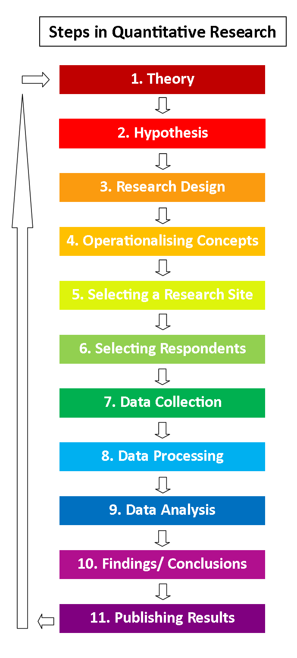

Figure 3.0

#### Methodology Activities

It starts with a theory which explains the concept of the system and where to go from

Furthermore the rest of the steps are explained as followed….

1. Hypothesis

The way that quantitative research gets going with hypothesis connotes the comprehensively logical way to deal with the connection among hypothesis and research in this practice. The humanistic hypothesis generally firmly connected with this approach is Functionalism, which is an improvement of the positivist beginnings of social science.

2. Speculation

It is normal frameworks of the fundamental stages of quantitative research to recommend that a speculation is found from the hypothesis and is tried.

Nonetheless, a lot of quantitative research doesn't involve the determination of a speculation, and on second thought hypothesis acts freely as a bunch of worries corresponding to which social researcher gathers information. The detail of theories to be tried is especially prone to be found in exploratory research however is much of the time found also in review research, which is generally founded on cross-sectional plan.

3. Research plan

The following stage involves the determination of a research plan which has suggestions for an assortment of issues, for example, the outer legitimacy of discoveries and researchers' capacity to credit causality to their discoveries.

4. Operationalising ideas

Operationalising ideas is an interaction where the researcher devises proportion of the ideas which she wishes to explore. This ordinarily includes separating conceptual humanistic ideas into additional particular estimates which can be effectively perceived by respondents. For instance, 'social class’s can be operationalized into 'occupation' and 'strength of strict accept' can be estimated by utilizing a scope of inquiries concerning 'thoughts regarding God' and 'participation at strict administrations'.

5. choice of a research site or locales

With lab tries, the site will currently be laid out, in field tests, this will include the determination of a field-site or locales, like an everyday schedule, while with review research, site-choice might be more shifted. Functional and moral variables will be a restricting component in decision of research destinations.

6. Choice of respondents

Stage six includes 'picking an example of members' to participate in the review - which can include quite a few inspecting strategies, contingent upon the speculation, and viable and moral elements. Assuming that the speculation requires examination between two distinct gatherings (people for instance), then, at that point, the example ought to mirror this.

Stage six might well go before stage five - on the off chance that you simply wish to research 'the degree of instructor naming in schools in London', then you're essentially restricted to finding schools in London as your research site(s).

7. Information assortment

Stage seven is a great many people's thought process of as 'doing research'. In exploratory research this is probably going to include pre-testing respondents, controlling the free factor for the trial gathering and afterward post-testing respondents. In cross-sectional research utilizing reviews, this will include meeting the example individuals by organized interview or utilizing a pre-coded survey. For observational research this will include watching the setting and conduct of individuals and afterward allotting classifications to every component of conduct.

8. Handling information

This implies changing data which has been gathered into 'information'. With some data this is a direct cycle - for instance, factors, for example, 'age', or 'pay' are now numeric.

Other data could should be 'coded' - or changed into numbers with the goal that it very well may be examined. Codes go about as labels that are put on information about individuals which permit the data to be handled by a PC.

9. Information examination

In sync nine, examining information, the researcher utilizes various factual strategies to search for critical relationships between factors, to check whether one variable essentially affects another variable.

The least difficult kind of strategy is to put together the connection between factors into diagrams, pie graphs and bar outlines, which give a prompt 'natural' visual impression of whether there is a critical relationship, and such devices are additionally indispensable for introducing the consequences of one's quantitative information examination to other people.

For quantitative research to be approached in a serious way, examination necessities to utilize various acknowledged measurable procedures, for example, the Chi-squared test, to test whether there is a connection between factors. This is exactly the piece that numerous human science understudies will loathe, however has become substantially more typical spot in the time of huge information!

10. Discoveries and ends

Based on the investigation of the information, the researcher should decipher the aftereffects of the examination. It is at this stage that the discoveries will arise: assuming there is a theory, is it upheld? What are the ramifications of the discoveries for the hypothetical thoughts that shaped the foundation of the research?

11. Reviewing Findings

At long last, in stage 11, the research should be reviewed. The research will compose for either a scholastic crowd, or a client, yet one way or another, a review should persuade the crowd that the research interaction has been hearty, that information is as legitimate, solid and agent as need might arise to be for the research purposes, and that the discoveries are significant with regards to previously existing research.

When the discoveries have been distributed, they become piece of the supply of information (or 'hypothesis' in the free feeling of the word) in their area. Hence, there is an input circle from stage eleven back up to stage one.

## System Analysis

* The system can add edit and delete arrivals departures and slots available, while being able to generate the complete invoice for the customer this all accounts to any need required from the system itself.
* The system allows the admin to register and log in where the admin can add edit and delete
* The system has a customer interface which allows the customer to view the available slots and select accordingly with the additional feature of the QR code and key in all the check in details required in the google forms
* Customer can pay with using another QR available (QR pay)

### Functional and Non-Functional Requirements

NON-FUNCTIONAL REQUIEMENTS:

* Usability
* Environment
* Reliability
* Localization

FUNCTIONAL REQUIREMENTS

* User sign in/register section
* LOG IN
* Arrival form
* Slots form
* Departure form
* Bill reservation form
* ADD/EDIT/DELETE (ARRIVAL,DEPARTUE,SLOTS)
* INVOICE generator
* Customer interface slot view
* QR slot selection
* QR pay

### Use Case Diagram

Register, login

Customer welcome page

View slots available

Admin

Customer



Add/edit/delete data

Print report

Print invoice

System update/manage

QR pay/slot select

Review/verify

Figure 3.1

### Use Case Descriptions

|  |  |
| --- | --- |
| UC #1 | Registration |
| ACTOR | ADMIN |
| Description | admin can register, login |
| Steps | 1. First admin must register 2. Admin must input username password and email in order to register. 3. admin may log in after putting email and password |

Table 3.0

### 

|  |  |
| --- | --- |
| UC #2 | Customer welcome page |
| ACTOR | CUSTOMER |
| Description | Customer can view the welcome page, and choose to “select slots” button which takes the customer to the main customer interface. |
| Steps | 1. customer must click the button on the welcome page stating “select slots” |

Table 3.1

### 

|  |  |
| --- | --- |
| UC #3 | Slots available |
| ACTOR | ADMIN, CUSTOMER |
| Description | Admin can view, add, edit, and delete slots from the slots available form.  Customer can view the available slots and select the slots to their choosing by scanning QR code |
| Steps | 1. Admin must log in 2. Admin comes to welcome page 3. Admin selects slots available 4. Admin can add/edit/delete and view/print report 5. Customer arrives in the customer interface 6. Customer views slots available 7. Customer selects by scanning the qr code 8. Selecting the slots in the link and input of details. 9. Slot selected. |

Table 3.2

### 

|  |  |
| --- | --- |
| UC #4 | Add, edit, delete data |
| ACTOR | ADMIN |
| Description | Admin can add, edit and delete data such as, departure logs, arrival logs, slots available logs |
| Steps | 1. Admin logs in 2. Admin goes to welcome page 3. Admin can select any category (departure,arrival,slots available) 4. Admin can add,edit and delete information manually. |

Table 3.3

### 

|  |  |
| --- | --- |
| UC #5 | Print report |
| ACTOR | ADMIN |
| Description | Admin can print report of (arrival departure, slots available and bill reservation) |
| Steps | 1. Admin selects category in main welcome page 2. Admin can view the data. 3. Admin can print out the data. |

Table 3.4

### 

|  |  |
| --- | --- |
| UC #6 | Print invoice |
| ACTOR | ADMIN, CUSTOMER |
| Description | Admin can generate and print invoice after selecting from the bill reservation.  Customer can QR scan in order to get invoice |
| Steps | 1. admin can select bill reservation form from the main welcome page.  2. admin can select the customer and click on invoice button to print out the complete invoice shown on the screen.   1. Customer can scan qr code and getting a generated invoice according to their own data. |

Table 3.5

### 

|  |  |
| --- | --- |
| UC #7 | System update/management |
| ACTOR | ADMIN |
| Description | ADMIN can update the system according to their or clients will, and manage it accordingly |
| Steps | 1. Admin can update the frame work of the system  2. admin can update and manage the design  Admin can add/delete attributes and categories.  3.admin can manage the system. |

Table 3.6

### 

|  |  |
| --- | --- |
| UC #8 | QR slot selection |
| ACTOR | CUSTOMER |
| Description | Customer can view the slots available in the parking with the occupancy/vacancy justified by red and green color for user easement |
| Steps | 1. Customer can scan the QR code 2. Customer can view the available vacant slots (lime green) occupied slots (red) 3. Customer can fill the check in form and select slot. |

Table 3.7

### 

|  |  |
| --- | --- |
| UC #9 | QR pay |
| ACTOR | CUSTOMER |
| Description | Customer can pay self-pay using QR to scan and pay the total amount online or via cash tto the worker booth |
| Steps | 1. Customer can scan the QR code 2. Customer can view the total amount 3. Customer can pay accordingly. |

Table 3.8

### 

|  |  |
| --- | --- |
| UC #10 | Review |
| ACTOR | ADMIN |
| Description | Admin can review all the data by selecting the category |
| Steps | 1. Admin can select any form and view the data available in the database of the system via grid view |

Table 3.9

## System Design

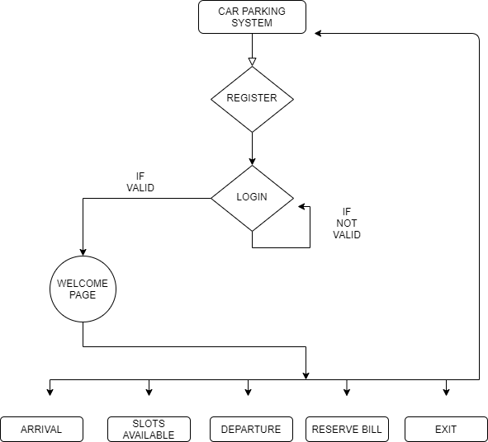

Figure 3.2

### Sequence Diagram

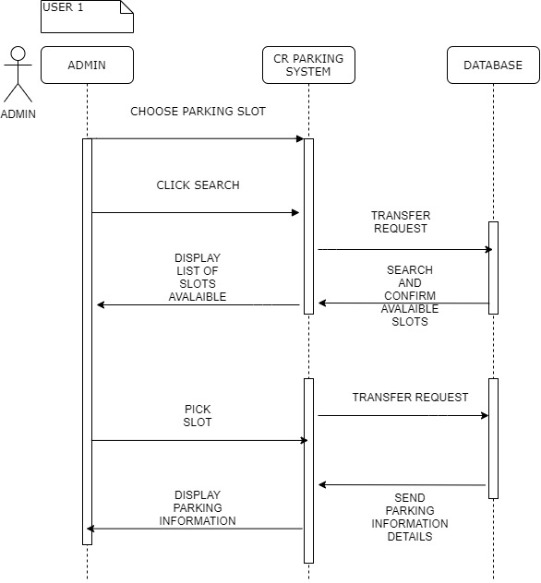

Figure 3.3

### Class Diagram

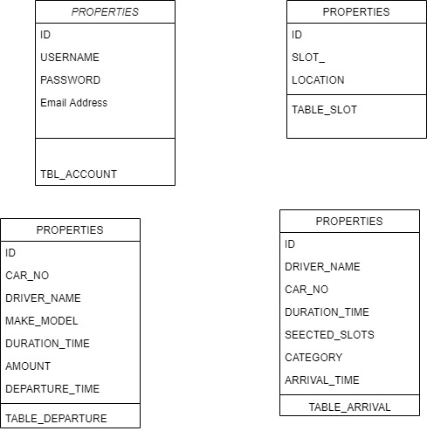

## Figure 3.4

### Data Dictionary (table 3.10)

|  |  |  |  |  |  |
| --- | --- | --- | --- | --- | --- |
|  | Field Name | Field length | Data Type | Data format | Description |
| PK | ID | 10 | int | Numerical | user ID, Auto generated |
|  | username | 30 | nvarchar | Numerical/text | Username of the client |
|  | password | 30 | nvarchar | Numerical/text | Password of the user |
|  | Slot_# | 10 | number | Numerical | Contact number of the client |
|  | Email | 40 | nvarchar | Numerical/text | User email address |
|  | Driver_name | 50 | nvarchar | Numerical/text | Name of the client |
|  | Car_no | 50 | nvarchar | Numerical/text | Licence plate number |
|  | Arrival_time | 50 | Date/time | dd-mmm-yyyy hh:mm:ss.s | Time of arrival |
|  | Departure_time | 50 | Date/time | dd-mmm-yyyy hh:mm:ss.s | Time of departure |
|  | location | 50 | nvarchar | Numerical/text | Parking slot location |
|  | Duration_time | 50 | nvarchar | Numerical/text | Parked time |
|  | category | 50 | nvarchar | Numerical/text | Hourly/daily |
|  | Make/model | 50 | nvarchar | Numerical/text | Production year and product name |
|  | amount | 18,0 | decimal | Decimal # | Money charge |

### TEST PLAN

|  |  |  |
| --- | --- | --- |
| Test Name (Testing Item) | Purpose of test/Test Procedure | Expected Output |
| REGISTRATION  TEST | Need to register in order to log in to the system later on.  User is required to key in their username, password and email. | In this event, user is sent to the log In page and their information is added into the database “table accounts” |
| LOG IN TEST | User need to log in to view the main welcome page for admin/clerk | Log in will take the user to the main welcome page in order to select the category of functions: arrival, slots. Departure, reservation and invoice |
| Arrival - add, edit, delete test. | User can add, edit delete arrival information.  Selecting the button after keying in appropriate data | In this event the user is able to add, edit and delete arrival car information from database grid view. |
| Arrival -error test | User inserts wrong data or information, or the car already parked | User gets message “this specific car already parked”, “box empty please fill details” and “error” |
| Arrival report test | User can print out the grid view report by clicking report button | Print setting pops up, for print type selection. |
| departure- add, edit, delete test. | User can depart, edit, delete departure information.  Selecting the button after keying in appropriate data | In this event the user is able to depart, edit and delete departure car information from database grid view. |
| Departure -error test | User inserts wrong data or information, or the car already parked | User gets message ”, “box empty please fill details” and “error” |
| Departure report test | User can print out the grid view report by clicking report button | Print setting pops up, for print type selection. |
| Reservation bill print | Reservation list is selected and print list button is clicked, in order to print out the reservation report | Print setting pops up, for print type selection. |
| INVOICE print test | Customer is selected then invoice button is clicked, which generates the customer invoice with all the customer details and total amount | Print button select then  Print setting pops up, for print type selection for the invoice. |
| Welcome customer page “pick slot” test | Customer view the only button and welcome message, in order to view the available slots customer must first select the “pick slots” button | Button sends the customer to the main customer interface. |
| Slot occupancy and vacancy test. | Clerk must update the slot availability by selecting occupied or vacant for each slots according to the customer selection. | Clicking occupied button turns the panel red.  Clicking vacant button turns the panel lime green. |

### Table 3.11

## Chapter Summary

This chapter covers all the diagrams and methodologies and activities performed to develop this project from functional requirements, non-functional requirements, comparison between similar systems. visualization of system design and interface is also provided with in depth analysis of the system design. This chapter will let the reader get a broader visualization of the project and help determine for the next chapter which will move to implementation of the website. Carrying all the data above and implementing on it to move forward and progress.

# CHAPTER 4 IMPLEMENTATION

## 4.0 Introduction

In The stage of Implementation is the process of developing the system when all the research has done with the functional requirements and the developer can move on to developing the system and To implement on the project which is focused on to build a car parking system. In this chapter author illustrates the UI design, system design, development details, database development details and how the system interacts with the user followed by testing and analysis ending with summary of the chapter.

## 4.1 Development Environment



Figure 4.1

* For the system design flowchart draw.io application was used in which the system flowchart is shown as above including register, login, and main page, with sub-context of: arrival, slots availability, departure, reservation bill details and exit which then returns the user to the login page .

**C# visual studio installer:**

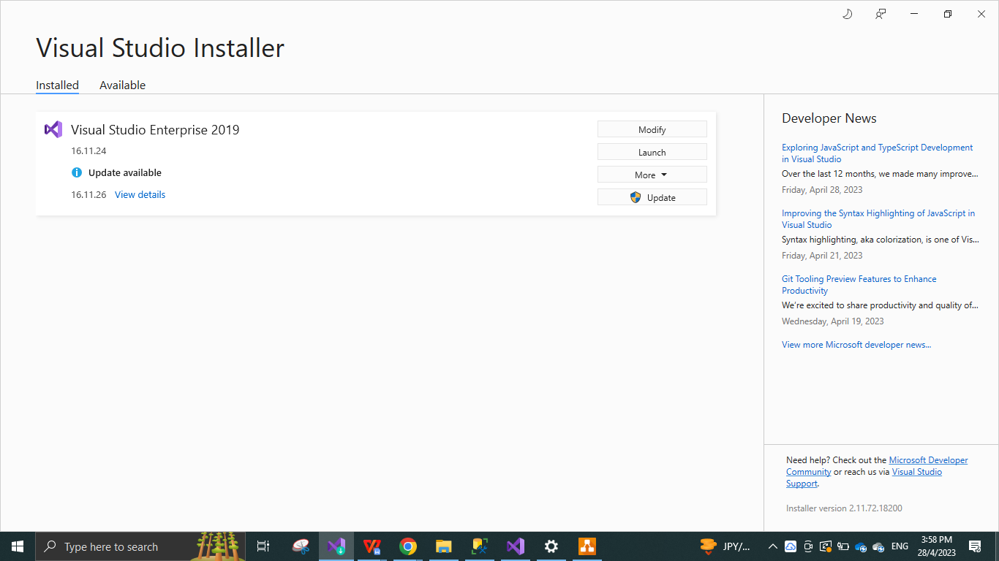

Figure 4.2

* Visual studios C # is used to develop The car parking system, which gives a lot of flexibility and mobility, when designing according to your will.

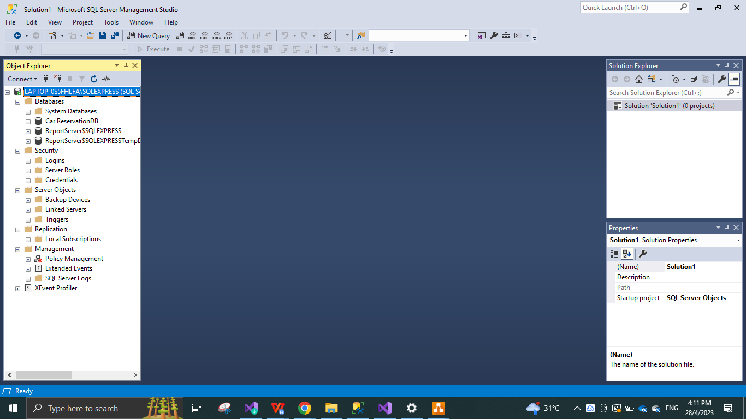

Figure 4.3

* For the database Microsoft SQL server 2014 is used, which is connected to the C sharp application and which collects stores and provides data collected or stored by the system.

## 4.2 System Development

System contains a registration page, login page with 5-6 sub-contents which are shown and listed below with descriptions.

**REGISTRATION PAGE**:

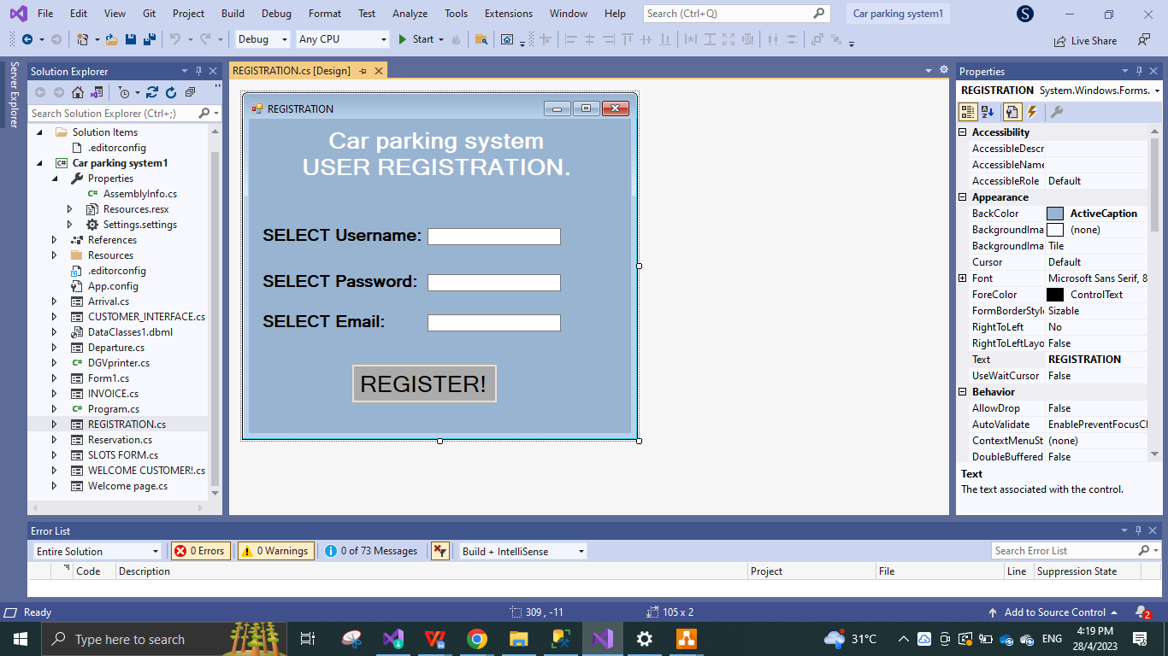

Figure 4.4

* This is the registration page for admin to register as a clerk for the parking system, it requires a user’s username, password and email in order to register.

**LOG IN PAGE:**

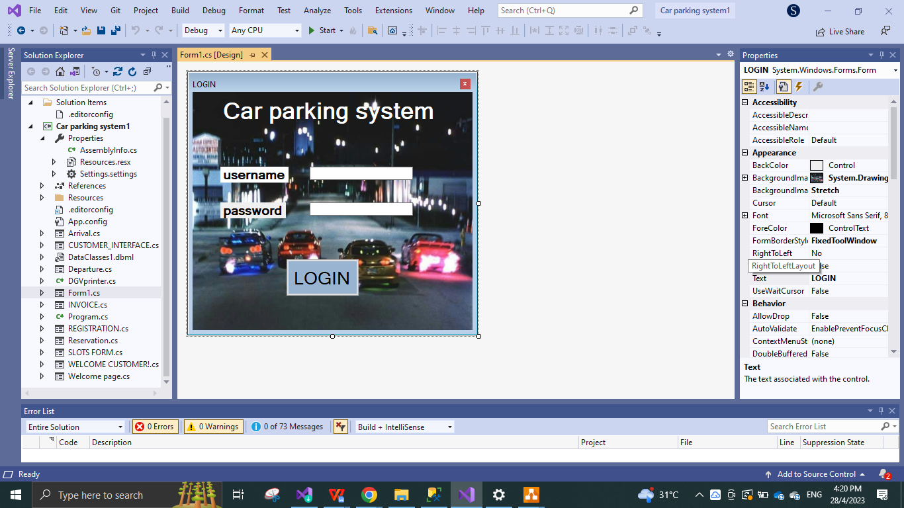

Figure 4.5

* This is the login page for the user where the user is only required to type in the username and password which the user used to register previously.

**MAIN WELCOME PAGE:**

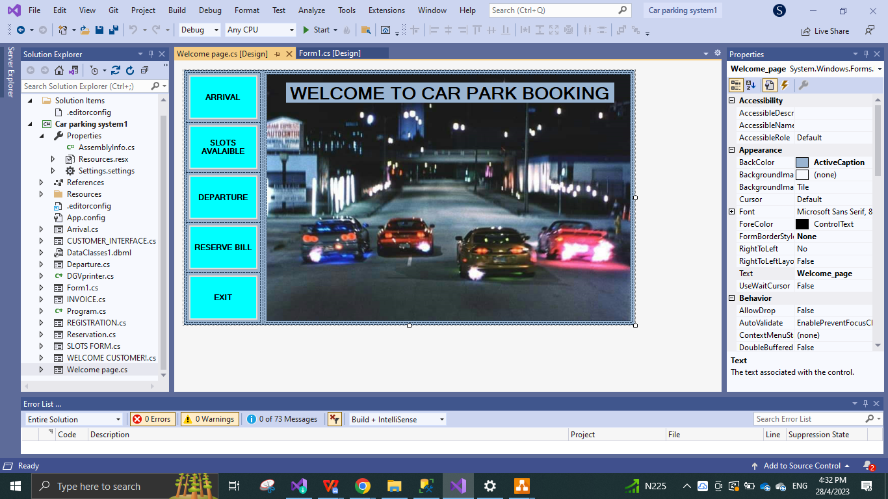

Figure 4.6

* This is the main welcome page for the car parking system, I consists of 5 buttons arrival, slots availability, departure, bill reservation and exit; each of them linked to their appropriate destination form pages.

**ARRIVAL FORM PAGE:**

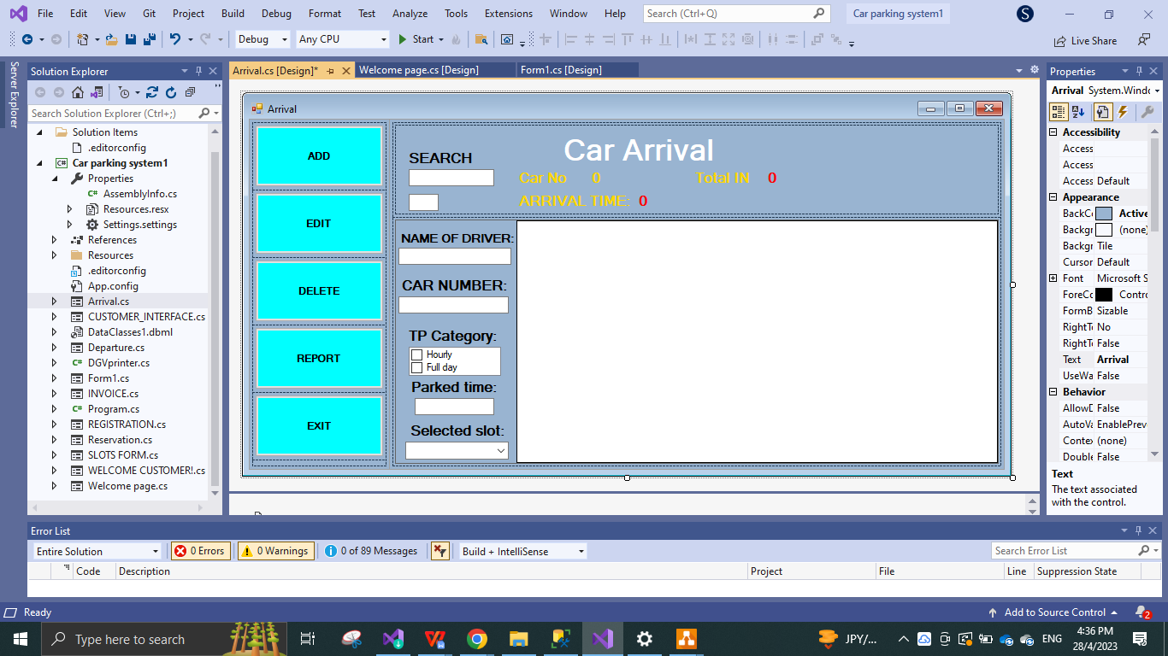

Figure 4.7

* This is the Arrival page where user can add, edit, delete the car, by using the provided details in the form. Report button allows the user to print out all the collected report of the arrival category.

**CAR SLOTS RECORD FORM:**

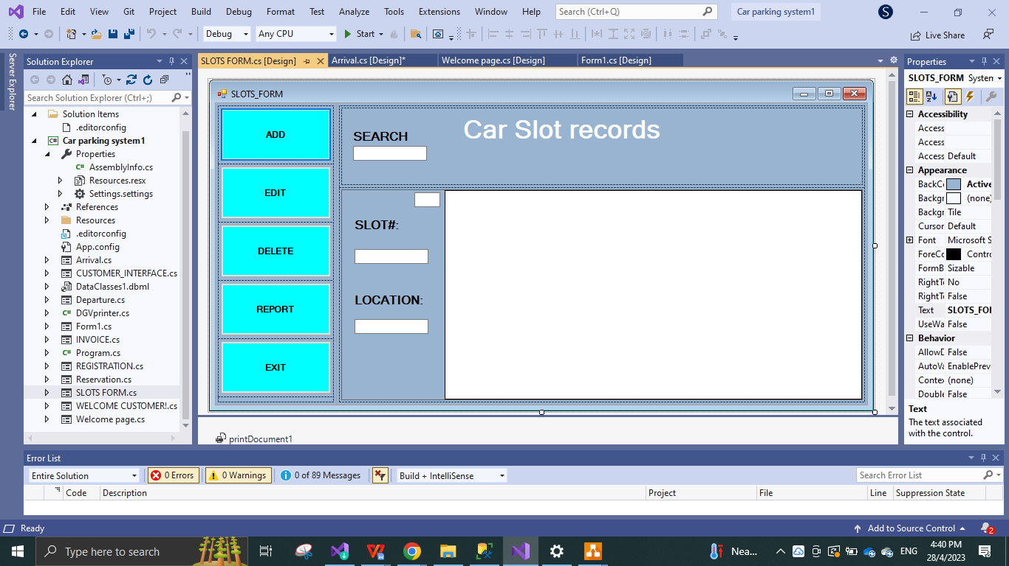

Figure 4.8

* This is the slots form page, where the user can add, edit and delete he slots, by typing in the slot number and location of the slot. The report button allows the user to print out all the collected details of the slot form category.

**DEPARTURE FORM PAGE:**

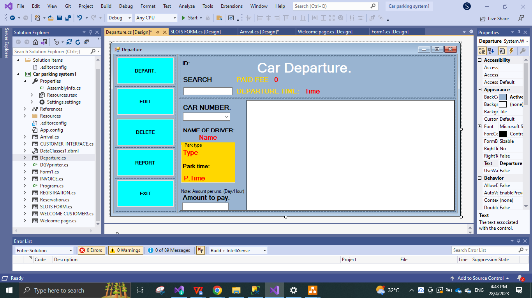

Figure 4.9

* This is the car Departure page, where the user can key in the departure of the car, edit the departure, delete the departure and print out the whole collected report by clicking the report button, it shows the amount details and the time the client has selected in this category of departure.

**RESERVATION DETAILS FORM PAGE:**

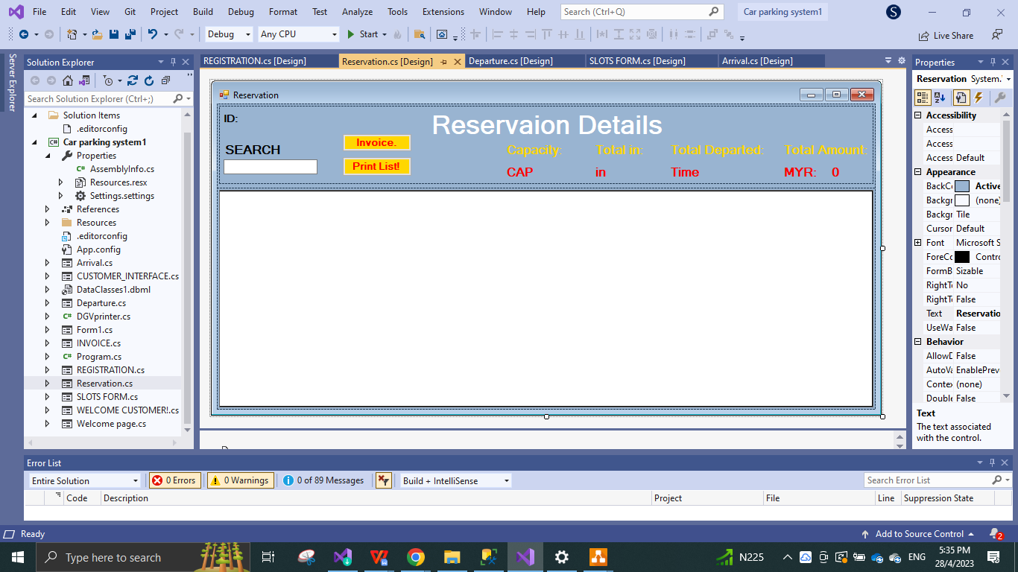

Figure 4.10

* This is the reservation details, in which the user can accumulate the total amount to pay for the client and is provided with the option to print the details and generate an invoice for the customer or admin where the invoice can also be printed out.

**INVOICE FORM PAGE:**

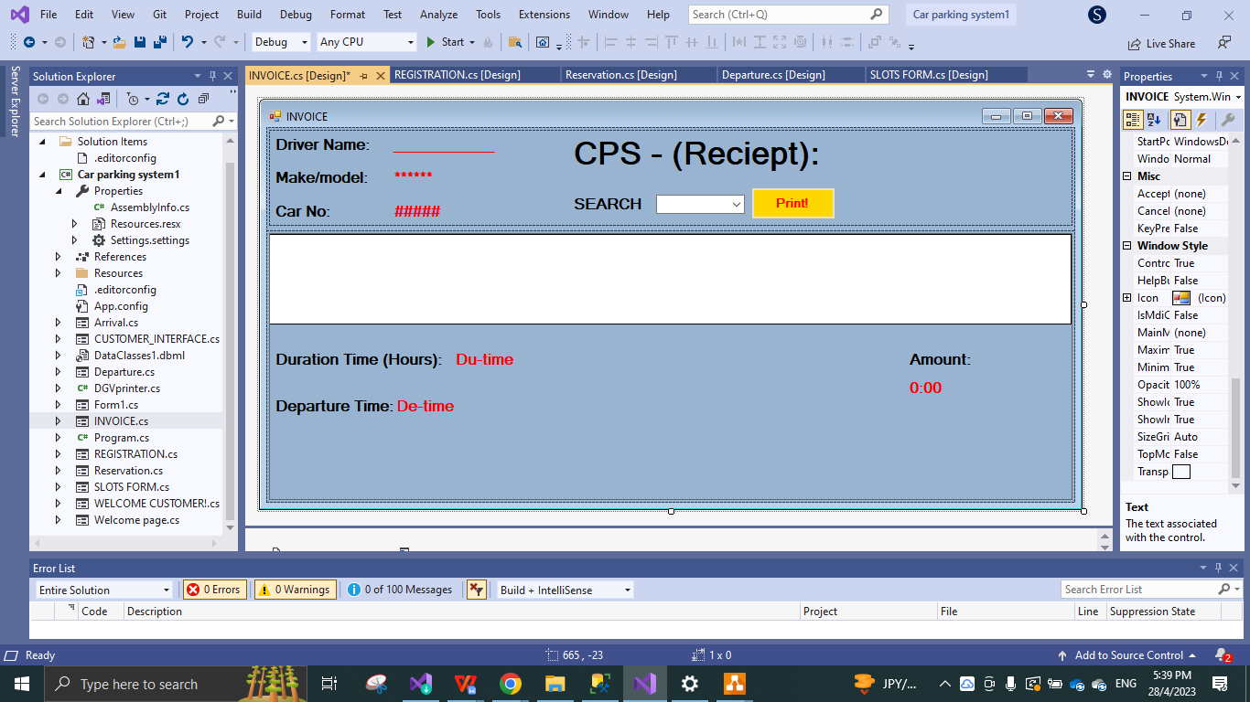

Figure 4.11

* This is the invoice form which is linked on the button available in the reservation details page. It displays all the timely information and car and customer details.

### 4.2.1 Database Development

The database used in this project as mention before is Microsoft SQL server 2014, which is linked to C sharp programming application.. and connected to a local server in this case my PC. This car parking system database consists of 4 table table_arrival, table_departure, table_slots and table account. which input and output the data collected or typed in or updated.

**DATABASE TABLES:**

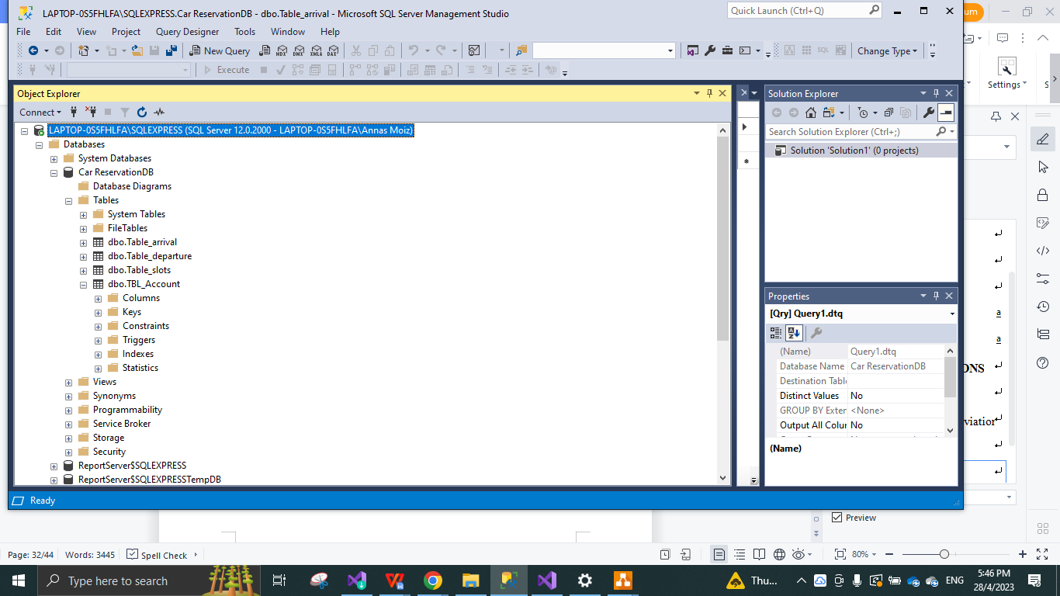

Figure 4.12

### 4.2.2 Client/customer Interface Development

**CUSTOMER WELCOME FORM PAGE:**

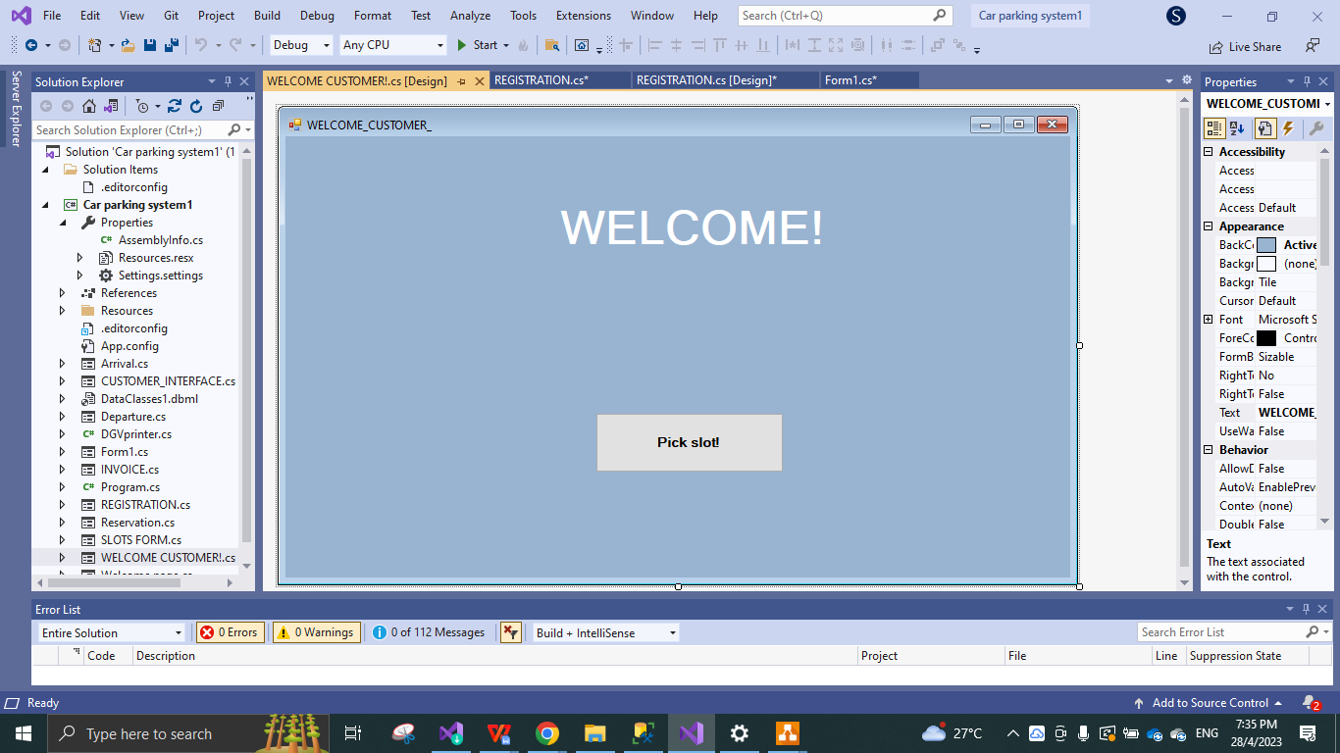

Figure 4.13

* This is the initial page the customer views, which takes the customer to the slot selection main interface.

**SLOT AVALABILITY/QR CHECK IN/QRPAY CUSTOMER INTERFACE PAGE:**

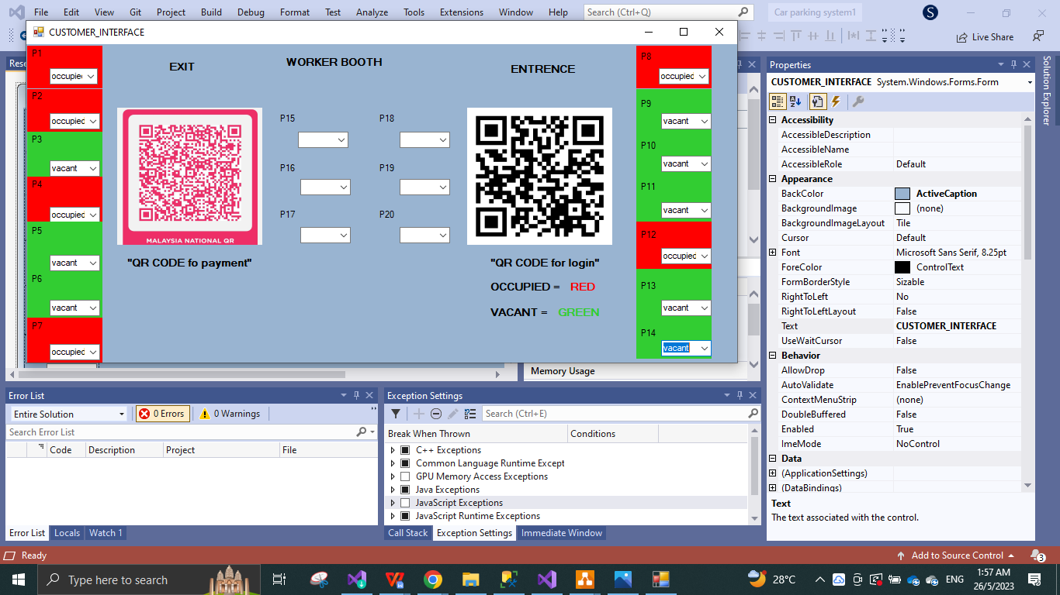

Figure 4.14

* This is the customer interface page, which acts as the main lobby for the customer self parking instead of clerk’s help, it is designed to illustrate the entrance, exit, and clerks office while showing the approx location of the parking slots. in this form are listed the numbered sots from p1-p20. 20 slots in total and when the form is opened the customer has the display showing the available slots in lime green and not available ones in red and function to scan qr code in order to key in all the data to the system and select the slots them selves while paying online using the pink QR code

**GOOGLE FORMS PAGES:**

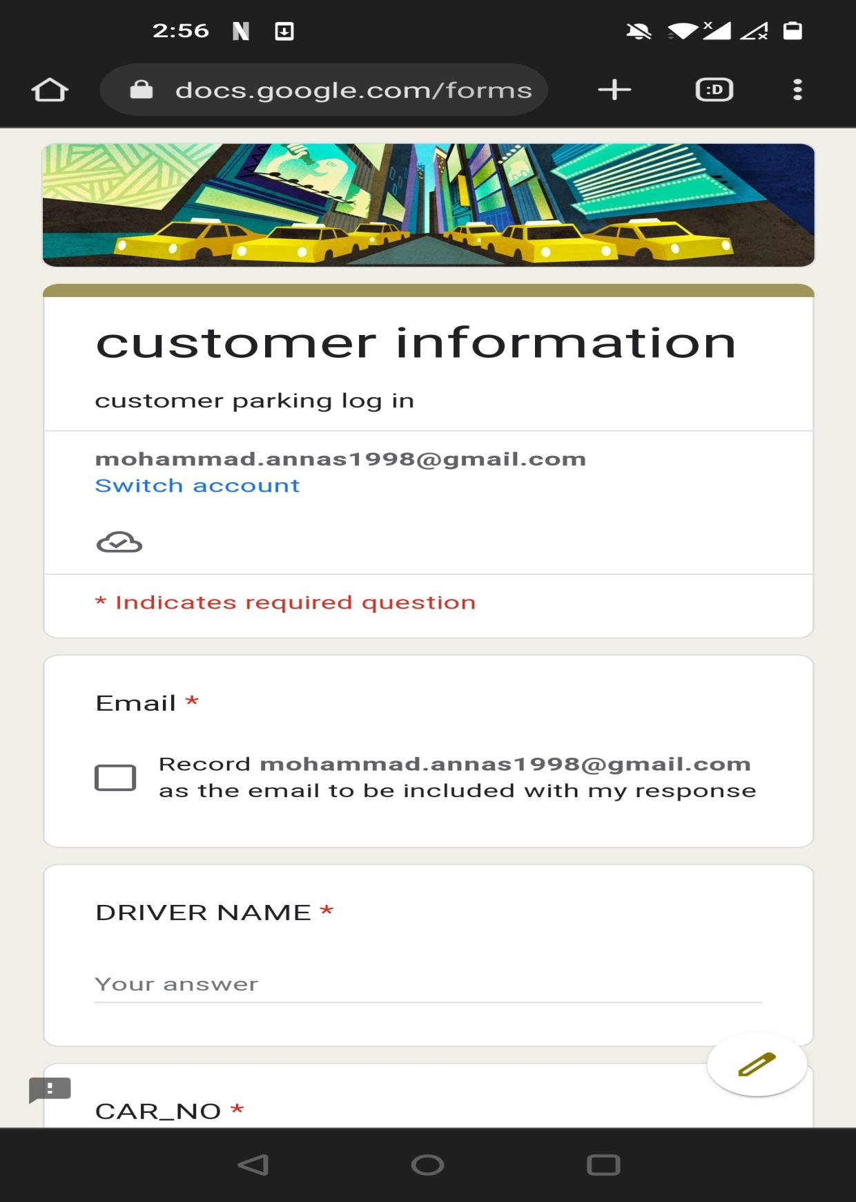

Figure 4.15

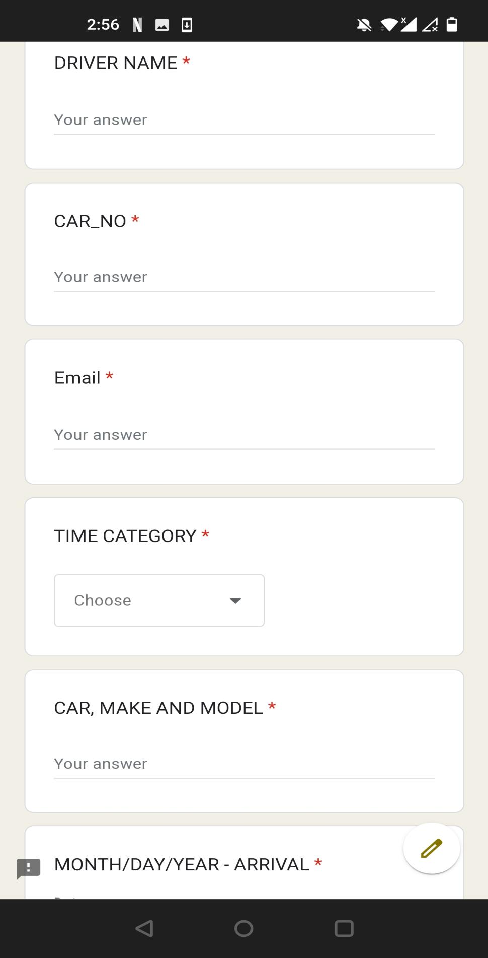

Figure 4.16

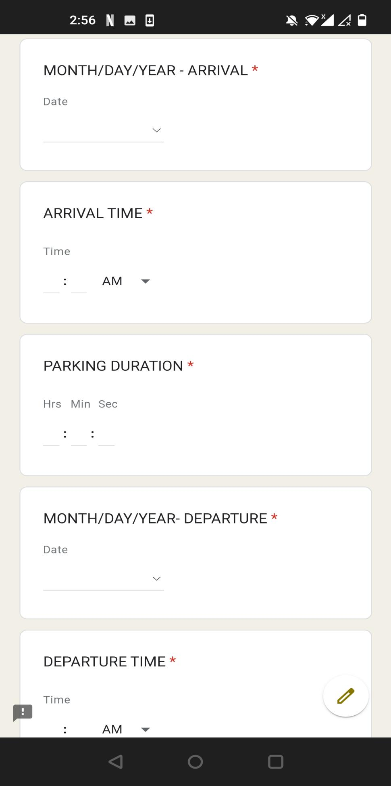

Figure 4.17

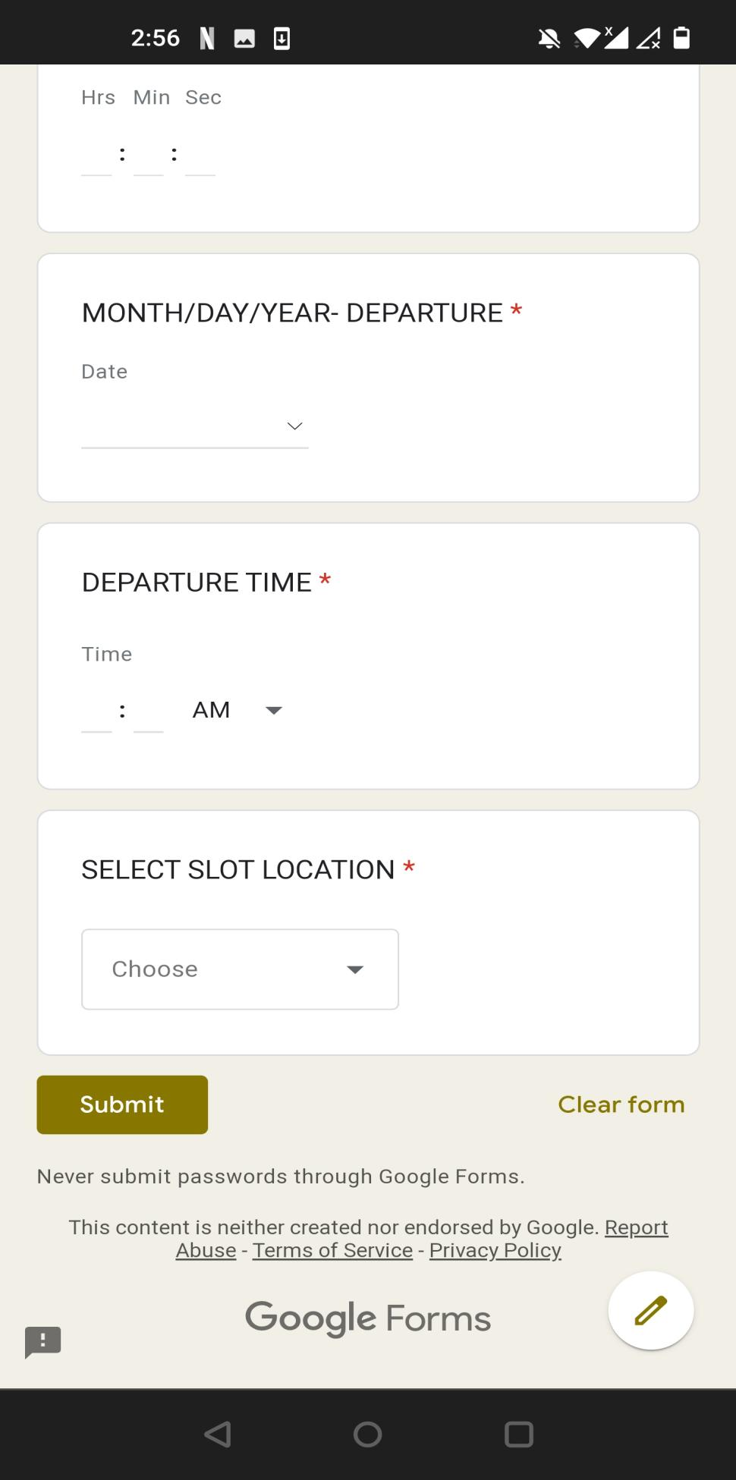

Figure 4.17

### 4.2.3 Programming Code Development

**REGISTRATION CODE:**

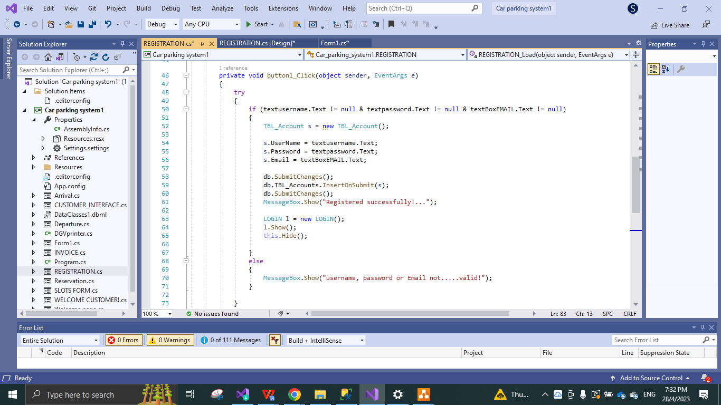

Figure 4.18

* REGISTRATION page code, uploads the data onto the accounts table in the database system.

**LOGIN PAGE CODE:**

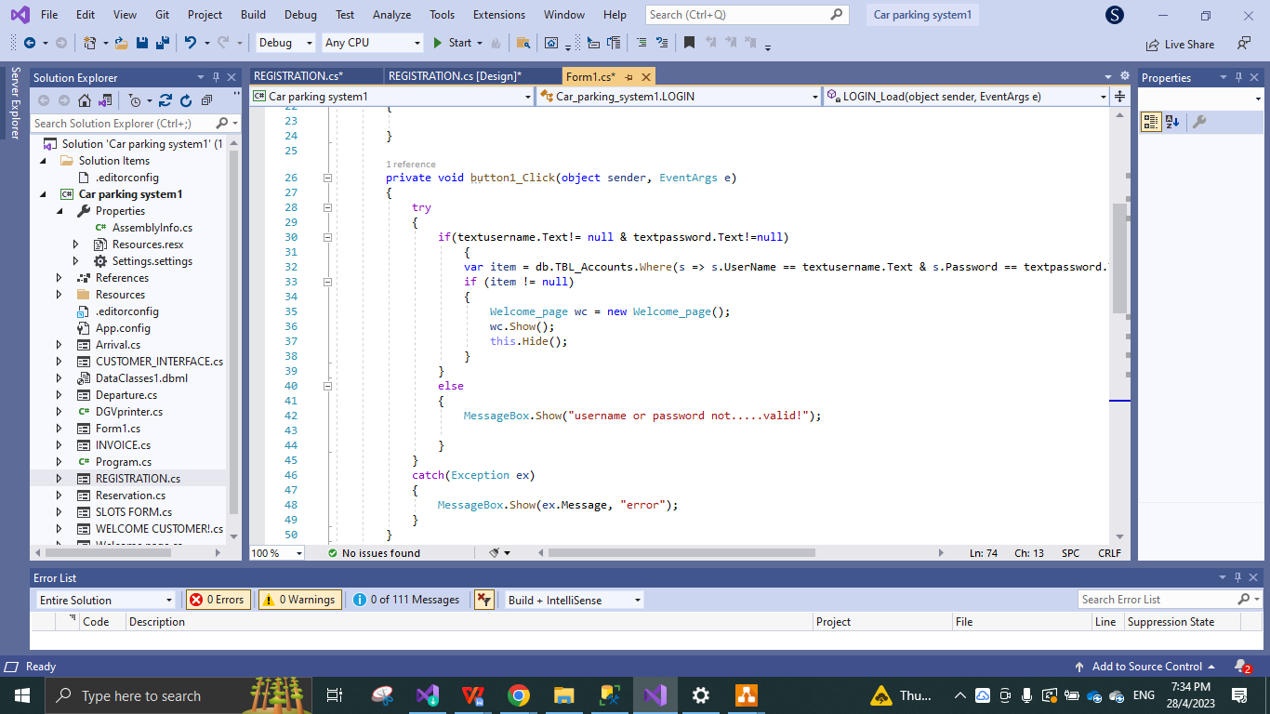

figure 4.19

* LOGIN FORM1 code, logs in the user onto he main welcome page.

**WELCOME PAGE CODE:**

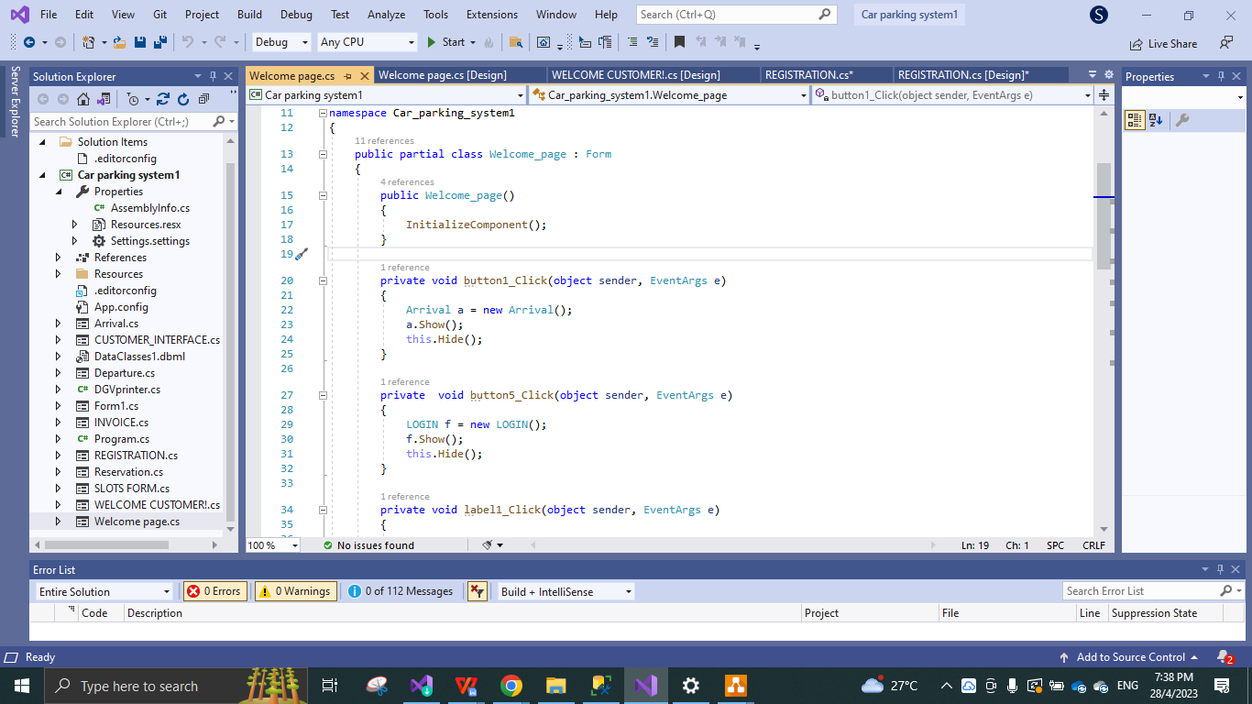

Figure 4.20

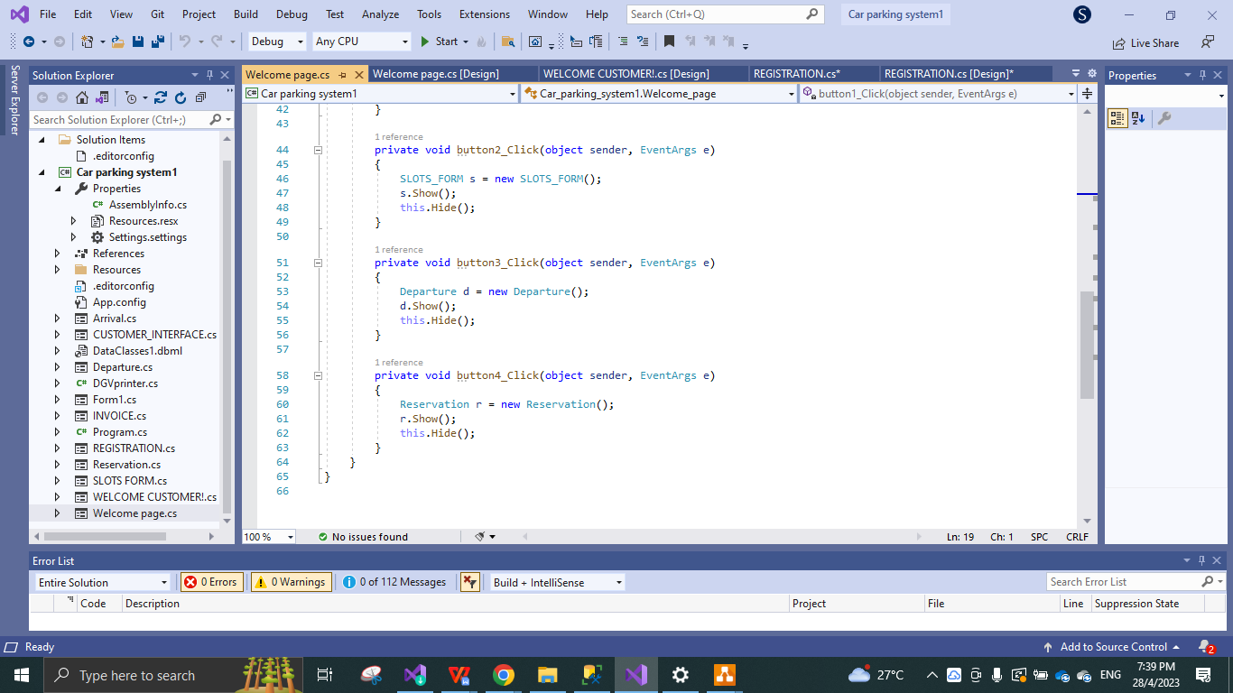

Figure 4.21

* These above are the code for directing each button onto the selected platform, developed in the main WELCOME PAGE for admin.

**ARRIVAL FORM PAGE:**

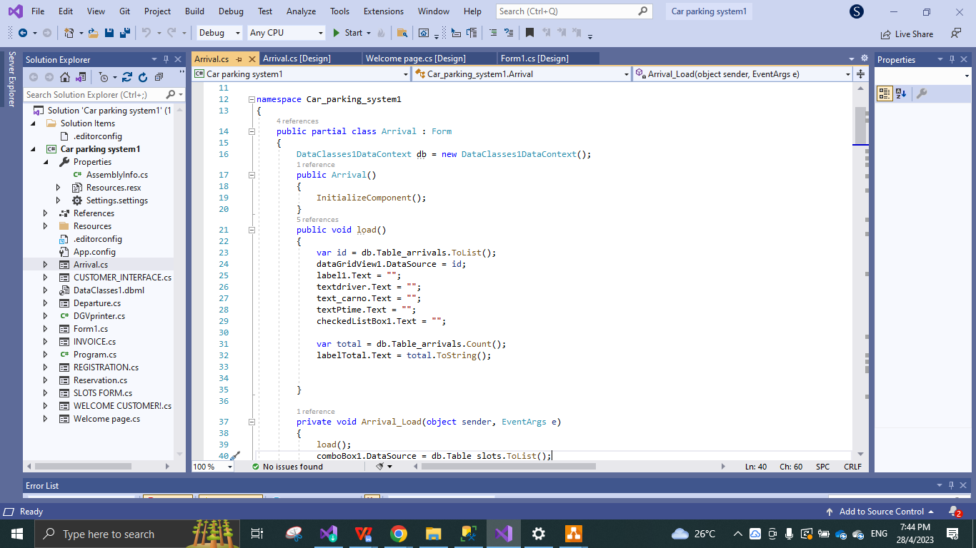

Figure 4.22

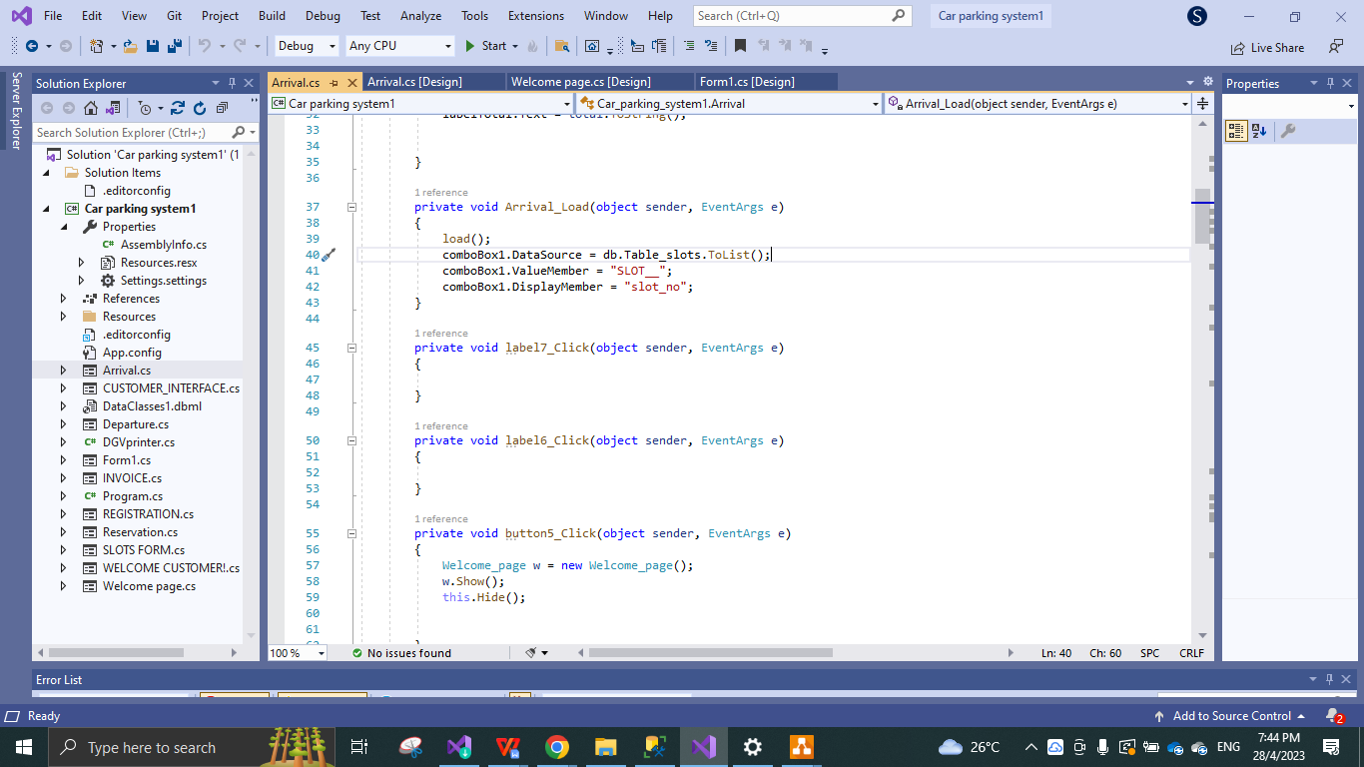

Figure 4.23

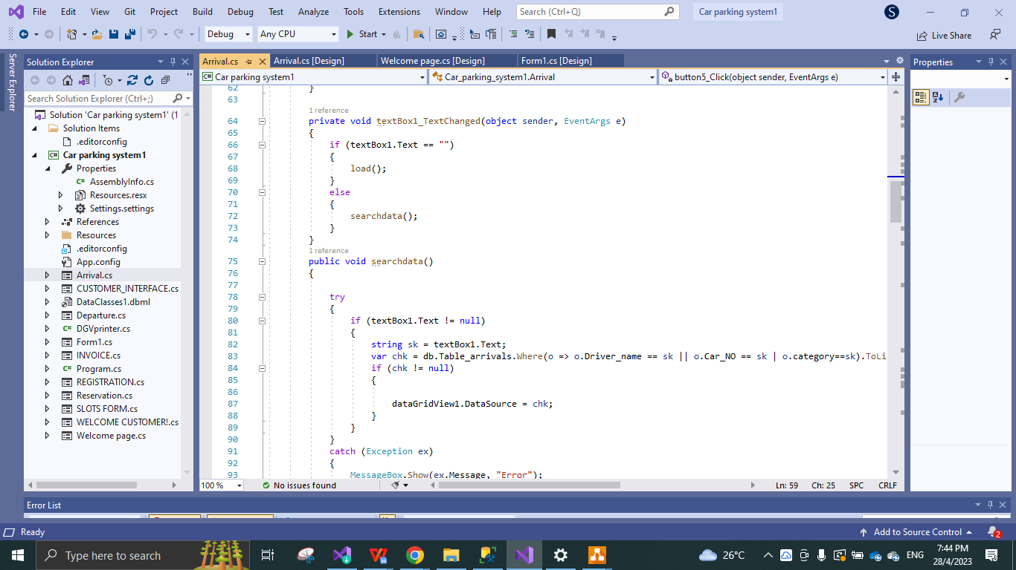

Figure 4.24

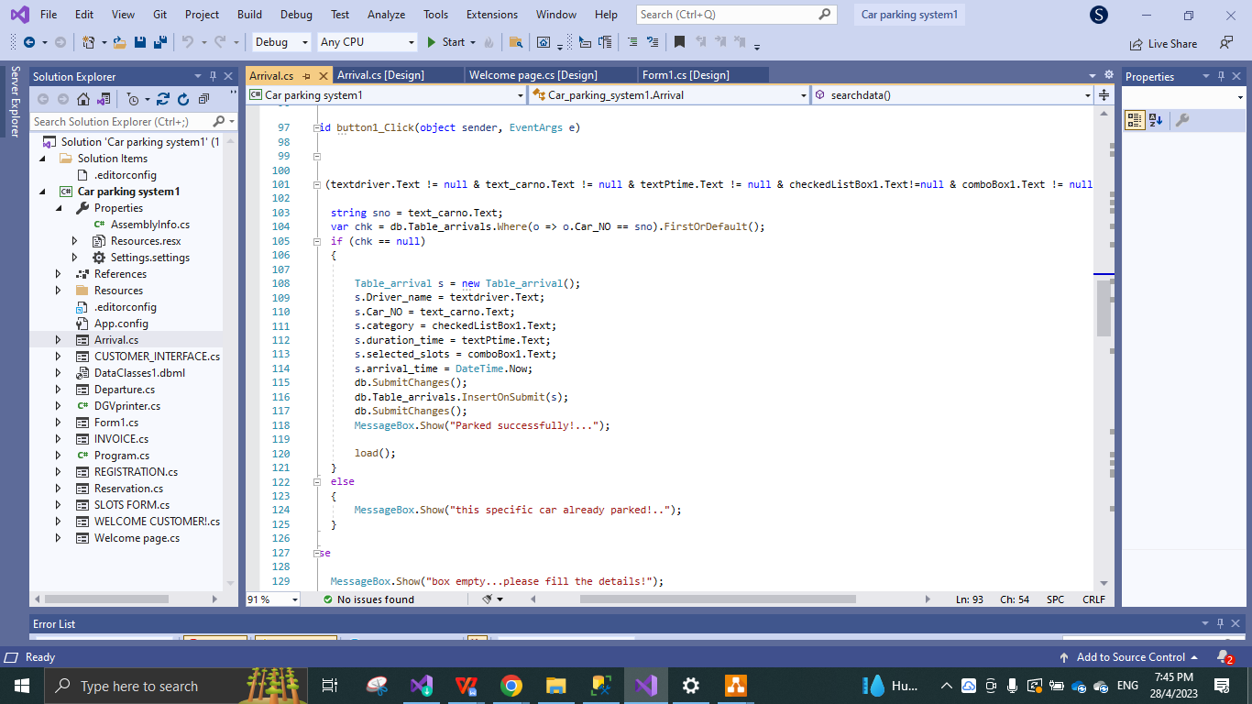

Figure 4.25

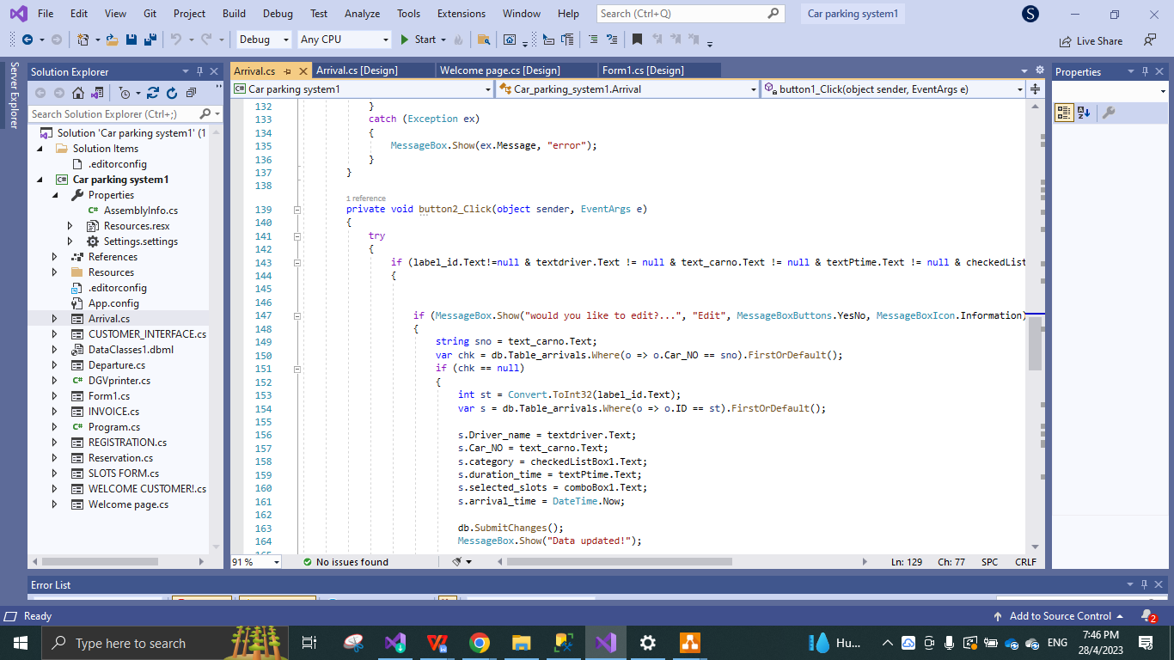

Figure 4.26

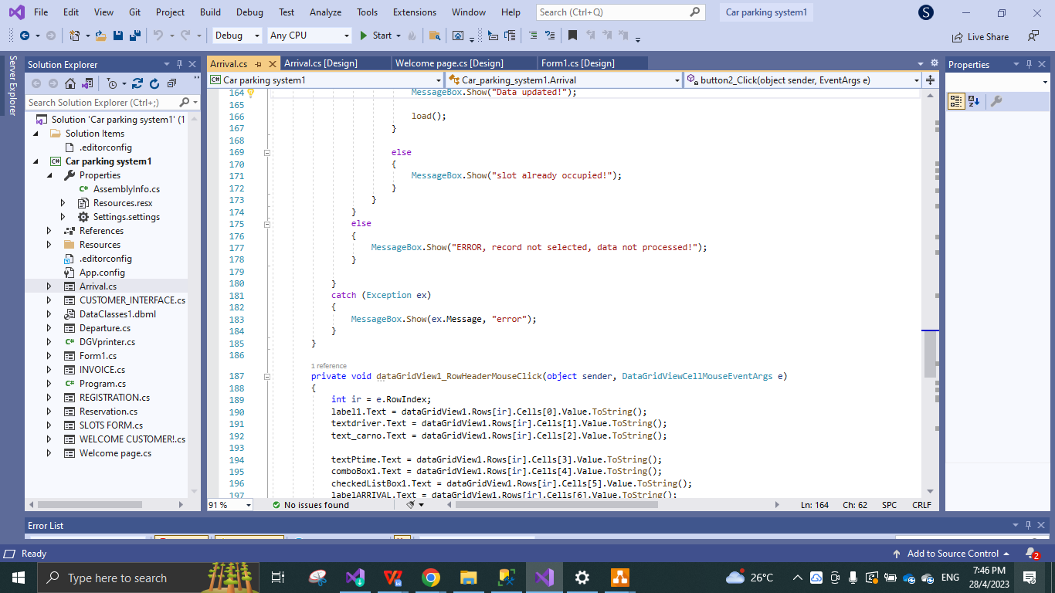

Figure 4.27

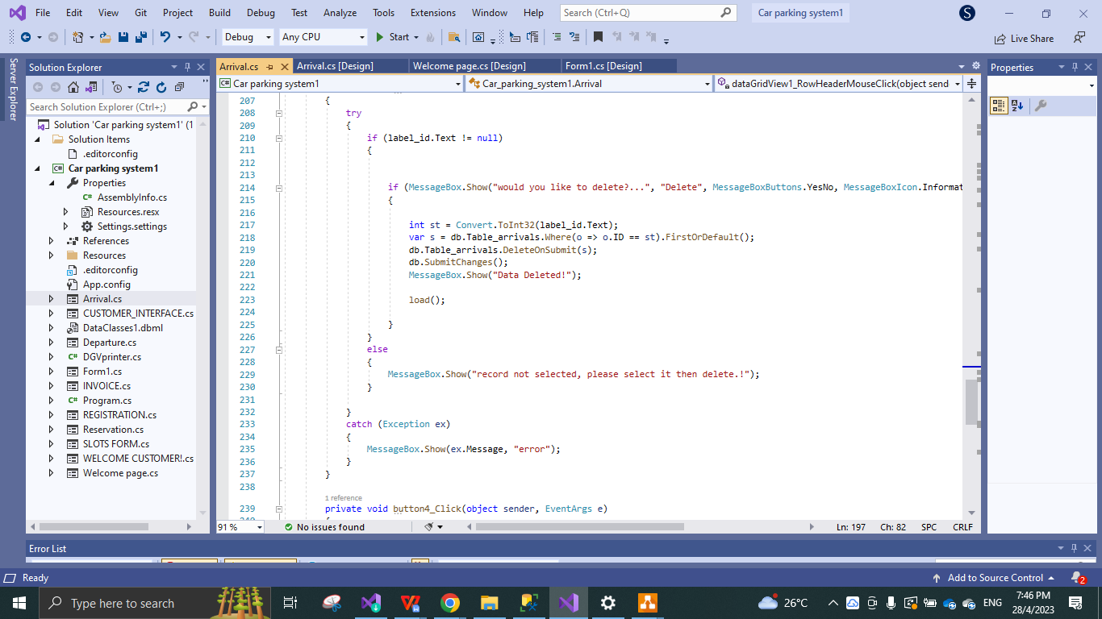

Figure 4.28

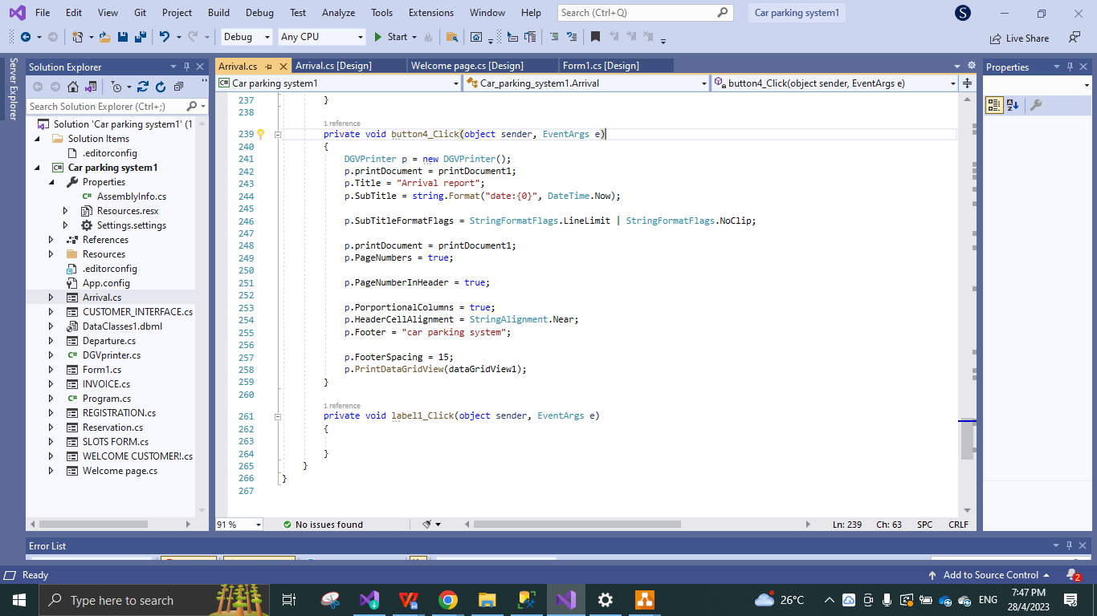

Figure 4.29

* The images above contain code for all the functions present in the ARRIVAL FORM.

**CODE FOR SLOT FORM PAGE:**

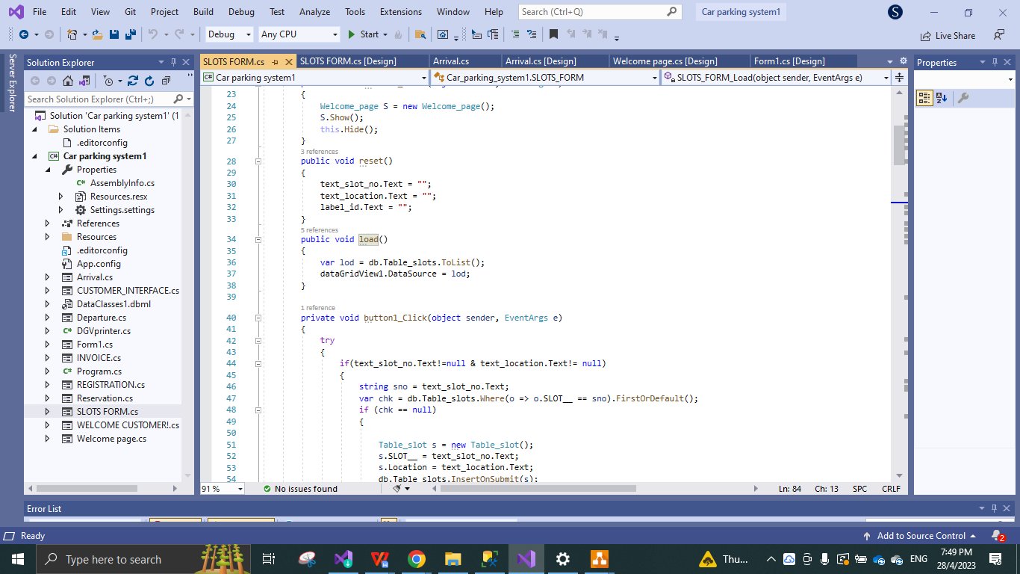

Figure 4.30

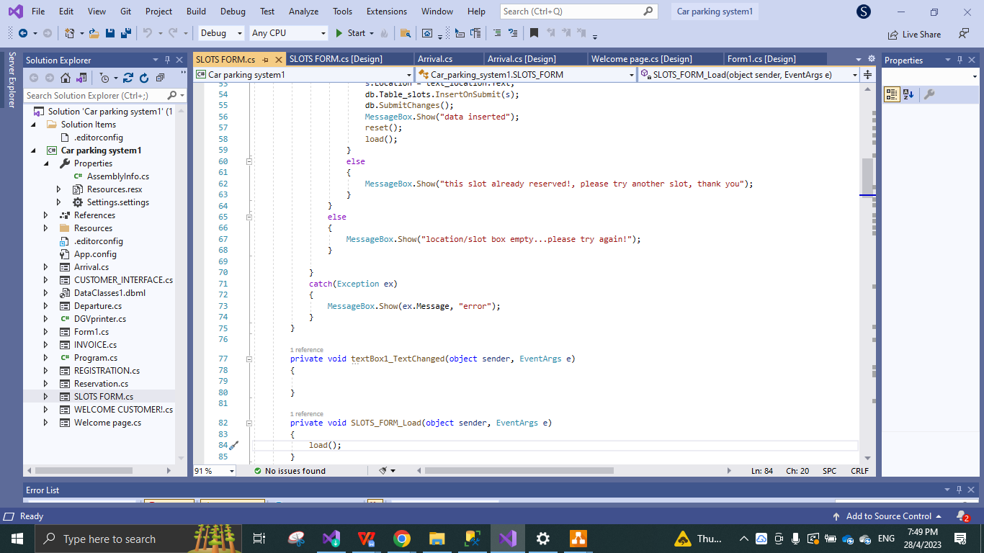

Figure 4.31

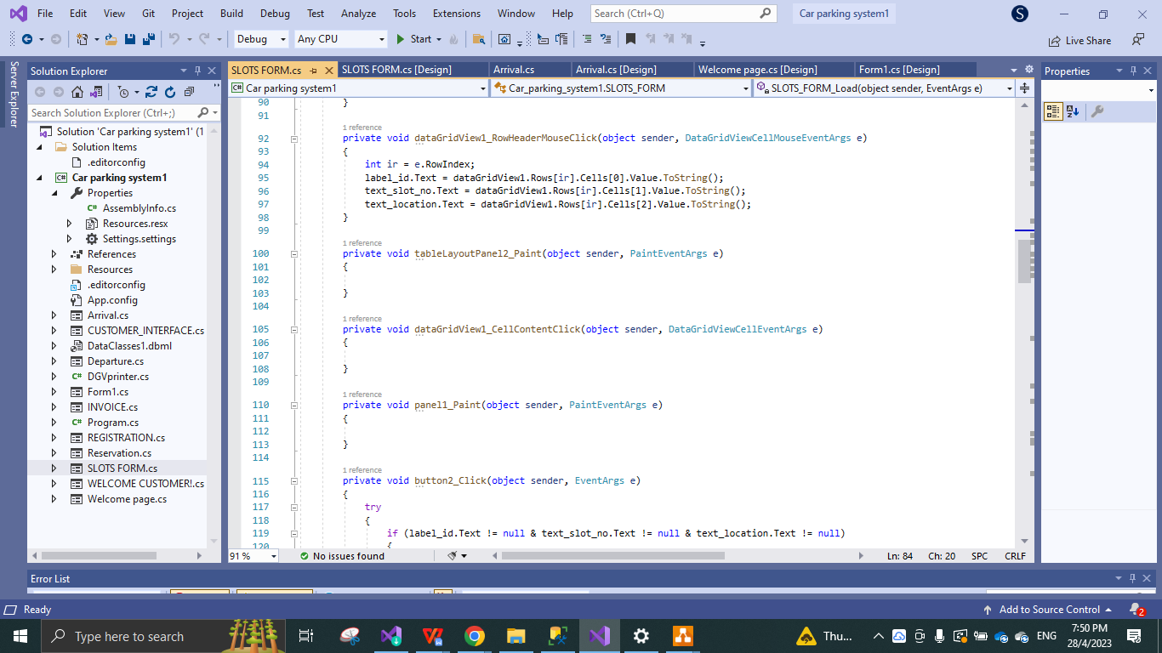

Figure 4.32

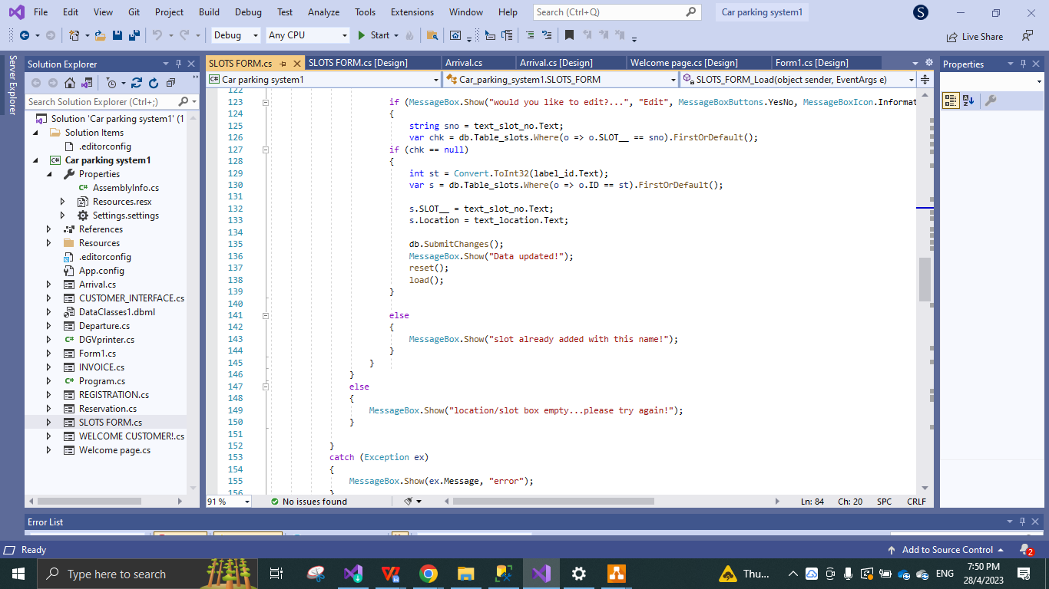

Figure 4.33

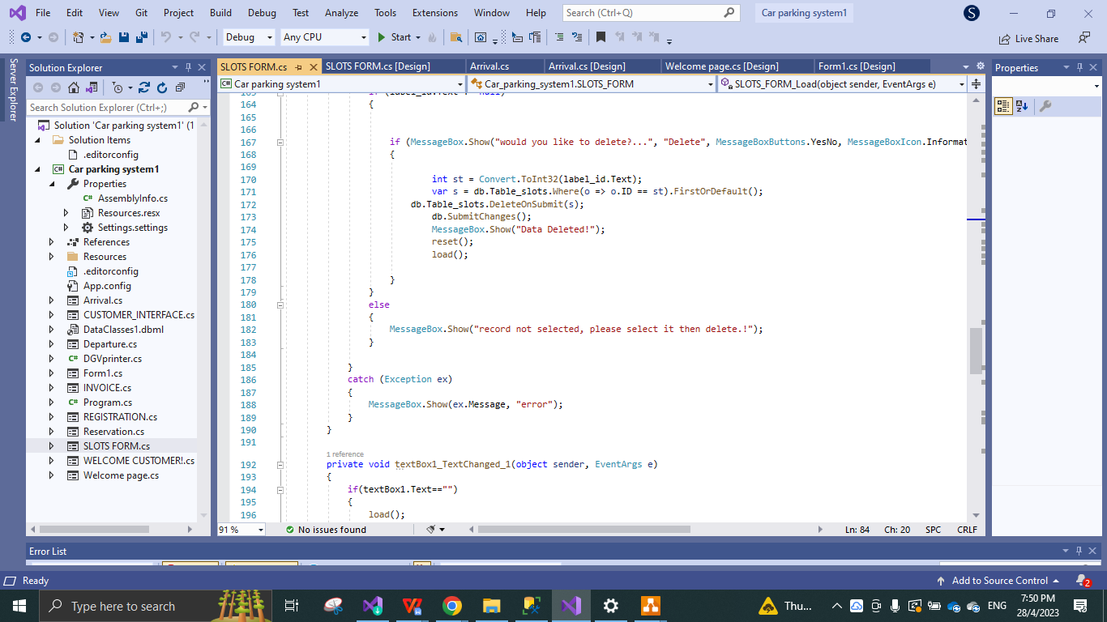

Figure 4.34

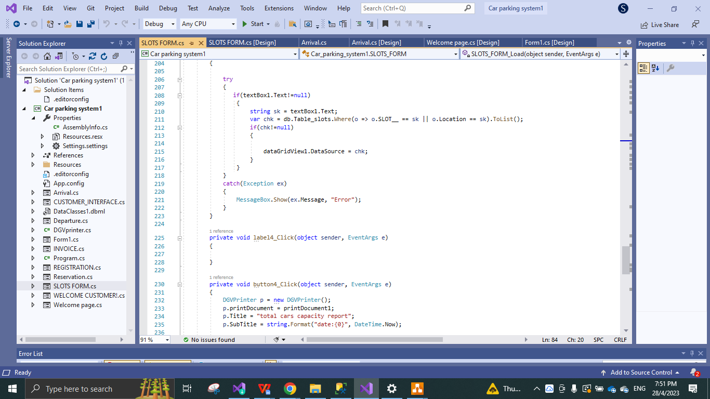

Figure 4.35

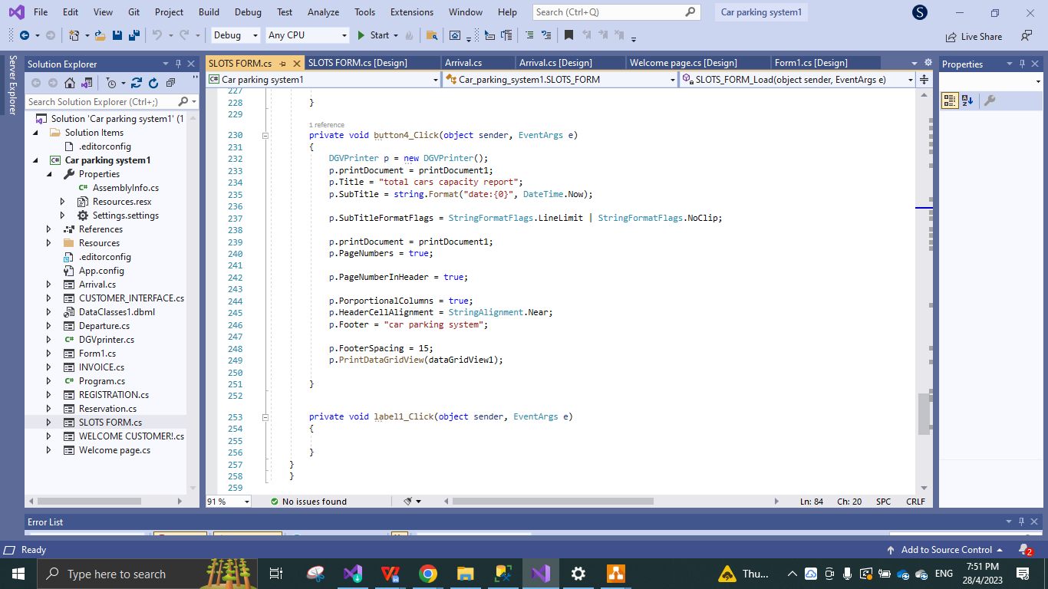

Figure 4.36

* Above images are the code of all the functions of the SLOT form for user.

**DEPARTURE PAGE CODE:**

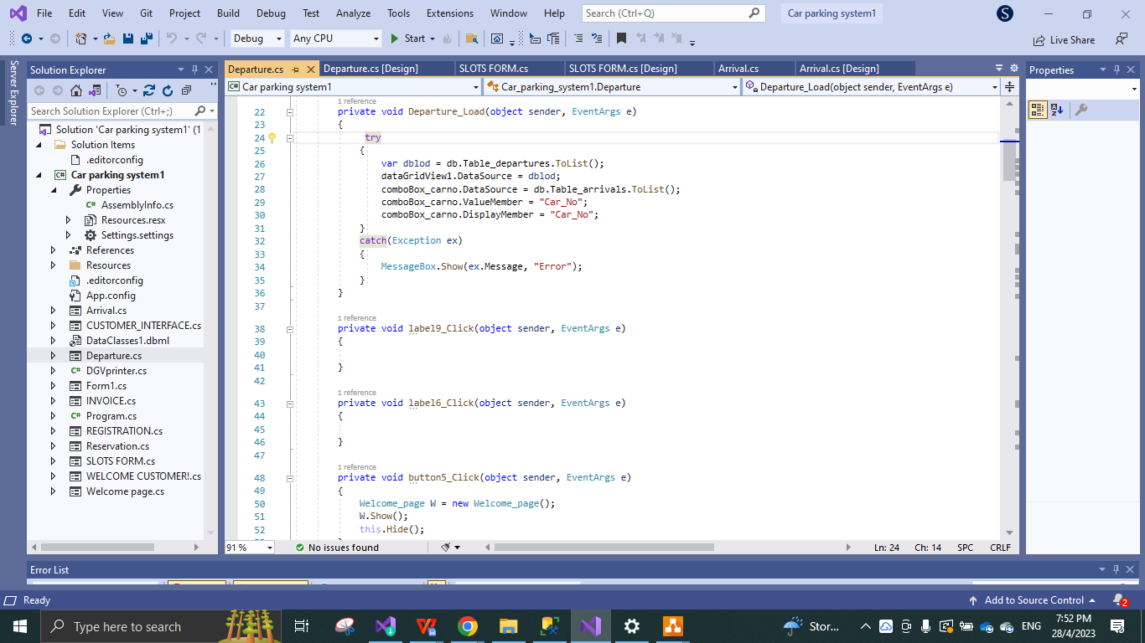

Figure 4.37

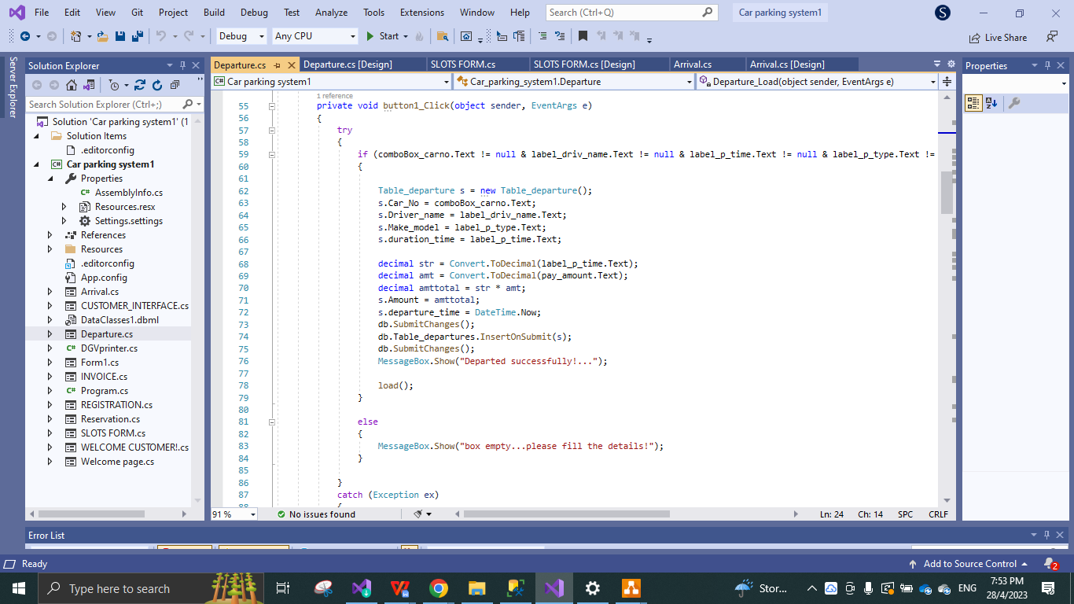

Figure 4.38

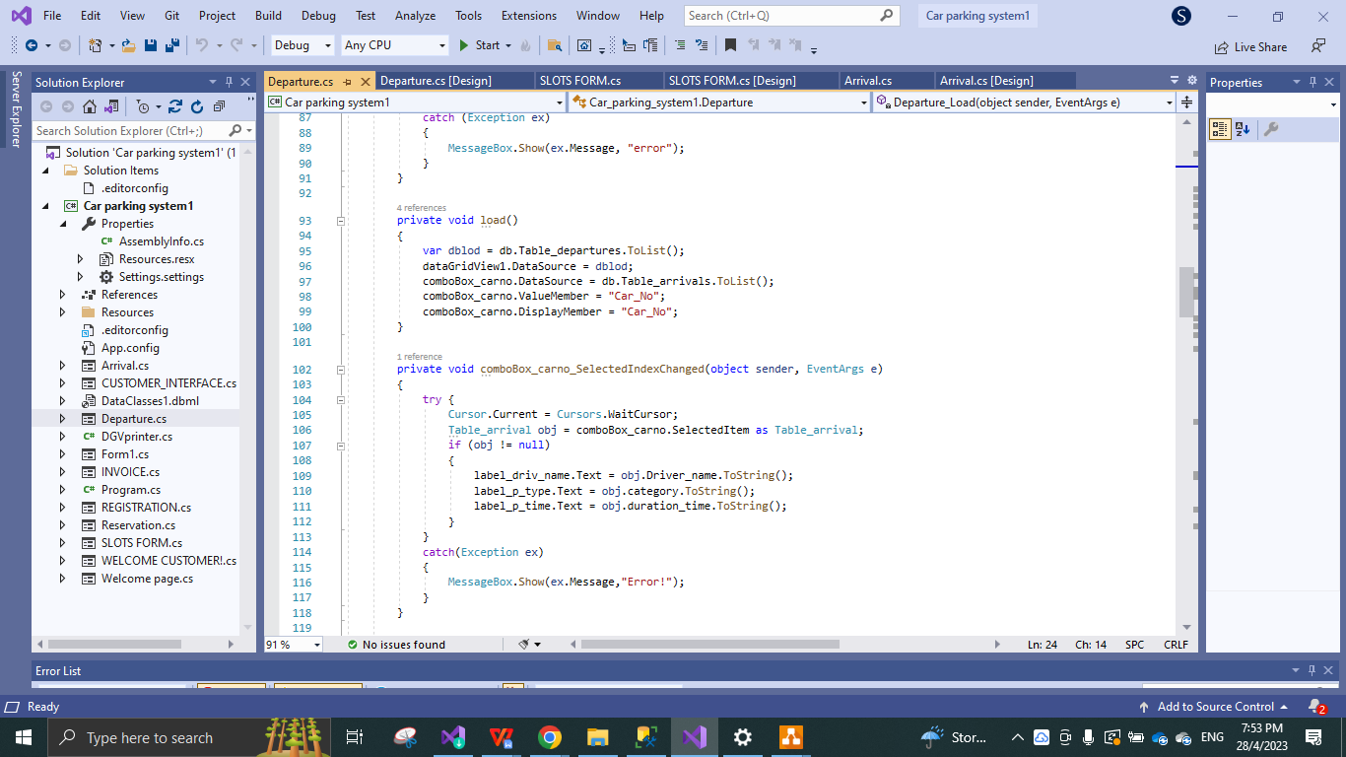

Figure 4.39

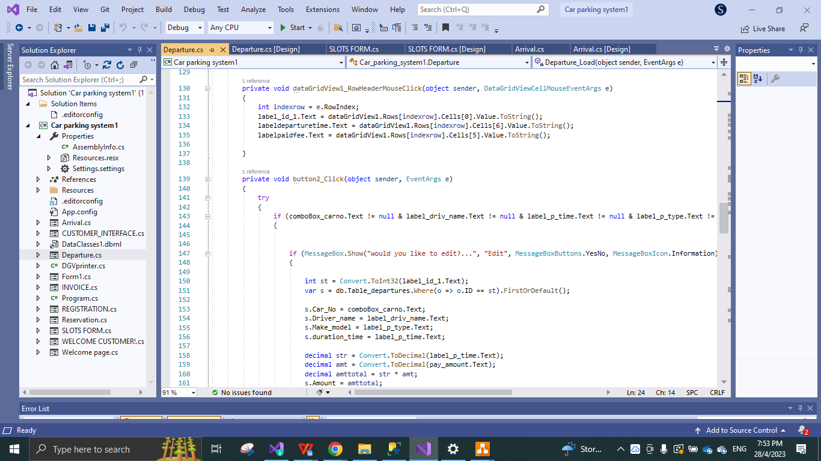

Figure 4.40

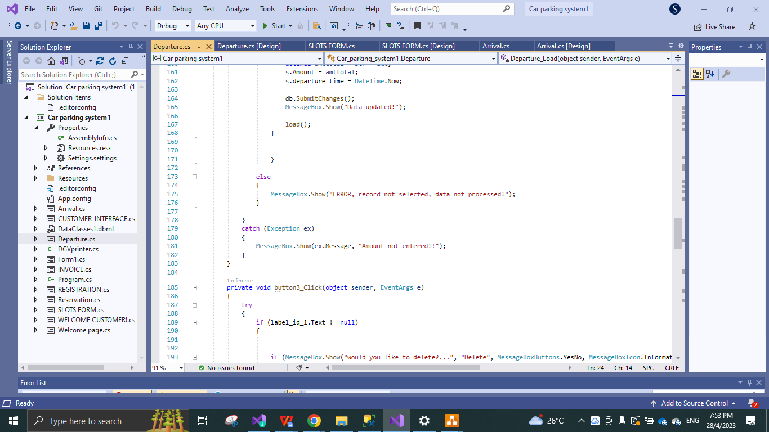

Figure 4.41

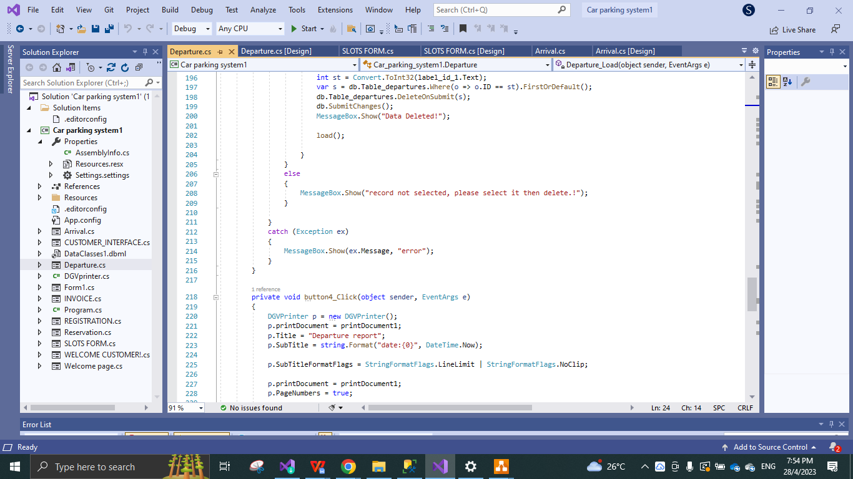

Figure 4.42

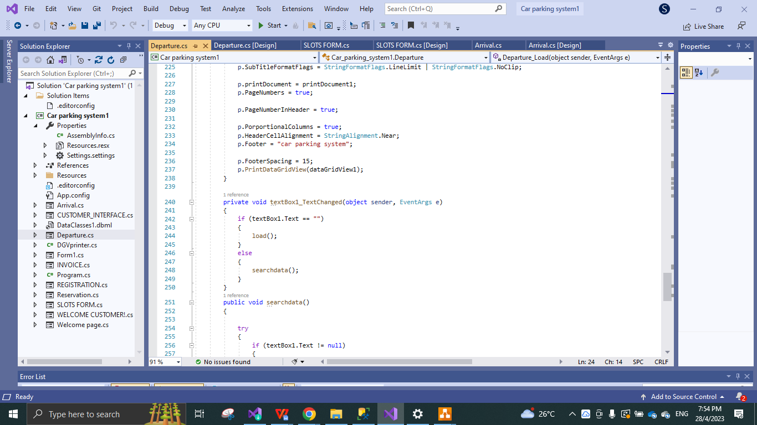

Figure 4.43

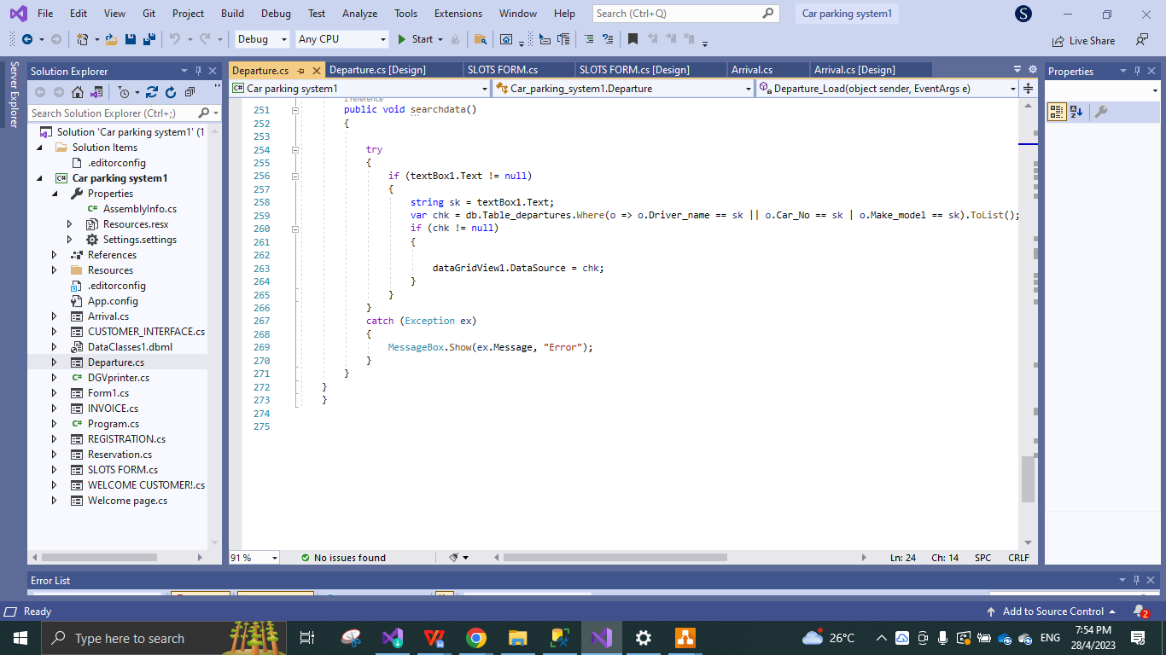

Figure 4.44

* Above images are the code for all the functions developed in the DEPARTUE form.

**RESERVE BILL FORM PAGE CODE:**

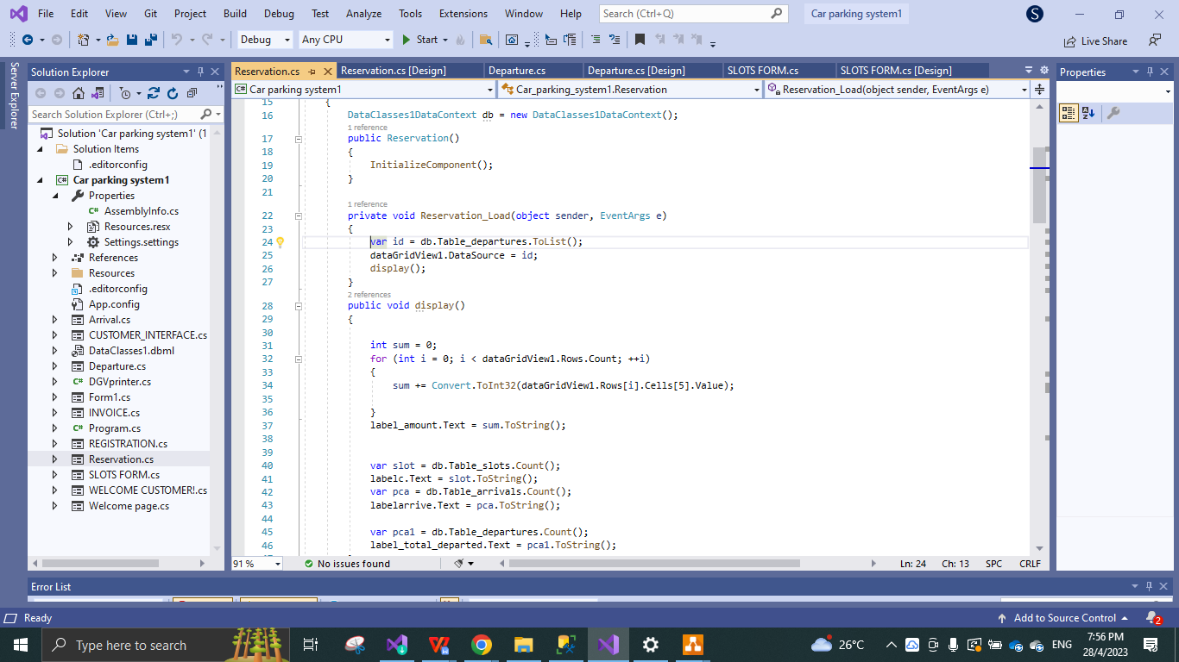

Figure 4.45

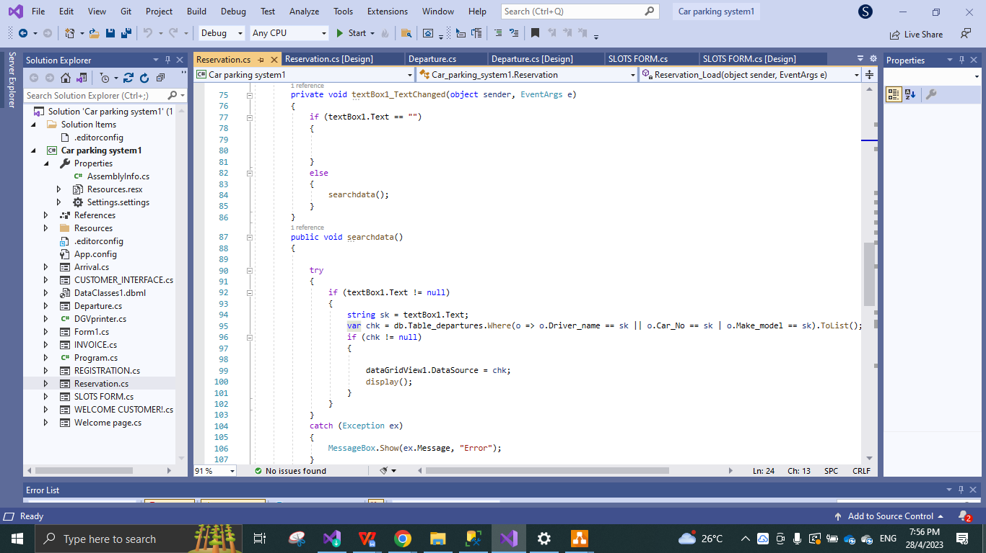

Figure 4.46

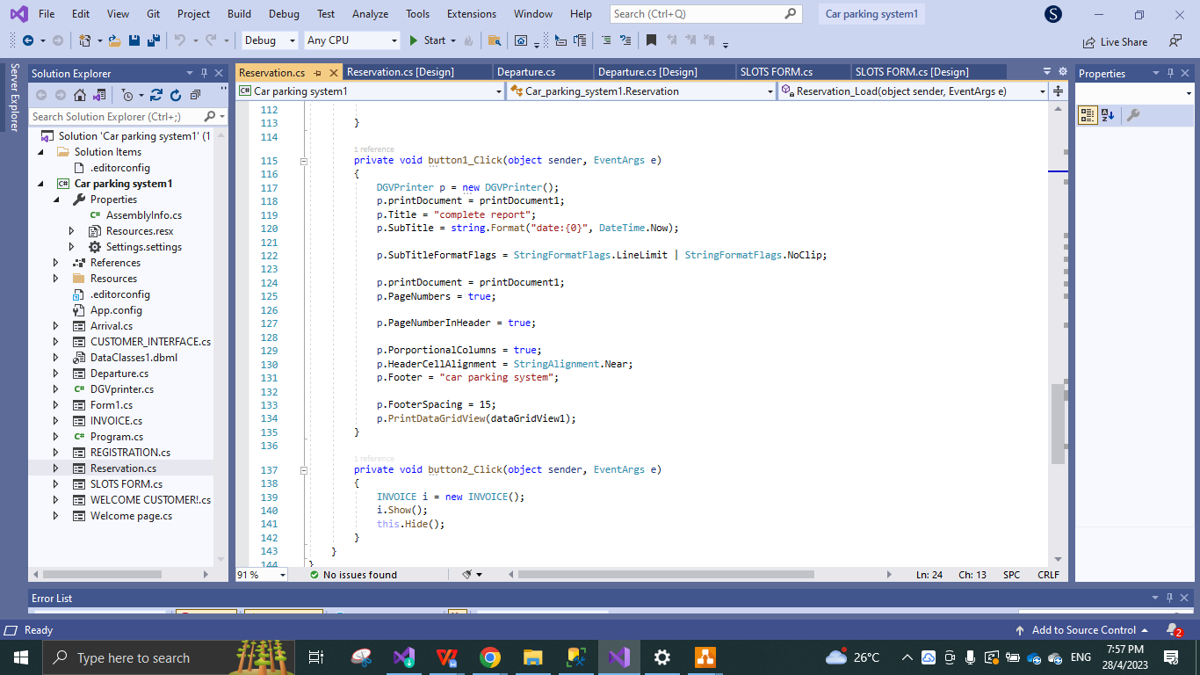

Figure 4.47

* Above images are code for all the functions developed in the RESERVE BILL form.

**INVOICE FORM PAGE CODE:**

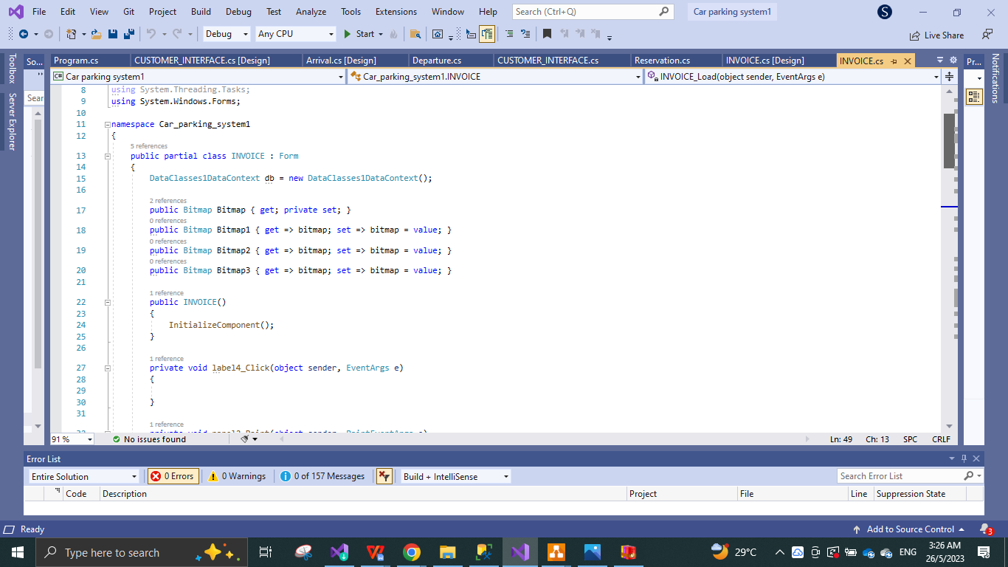

Figure 4.48

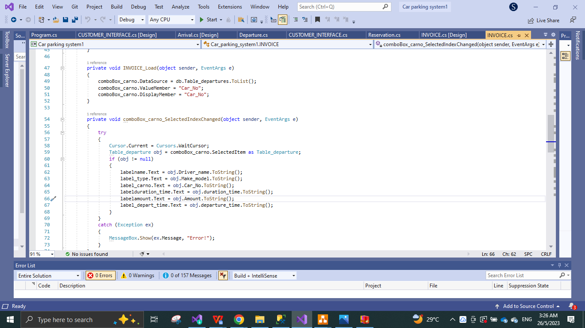

Figure 4.49

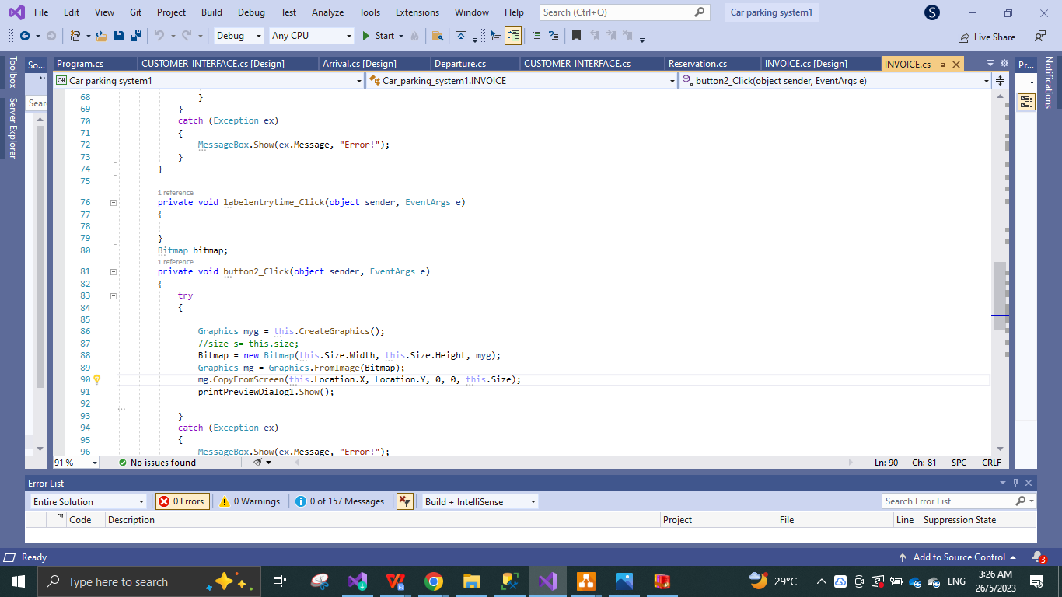

Figure 4.50

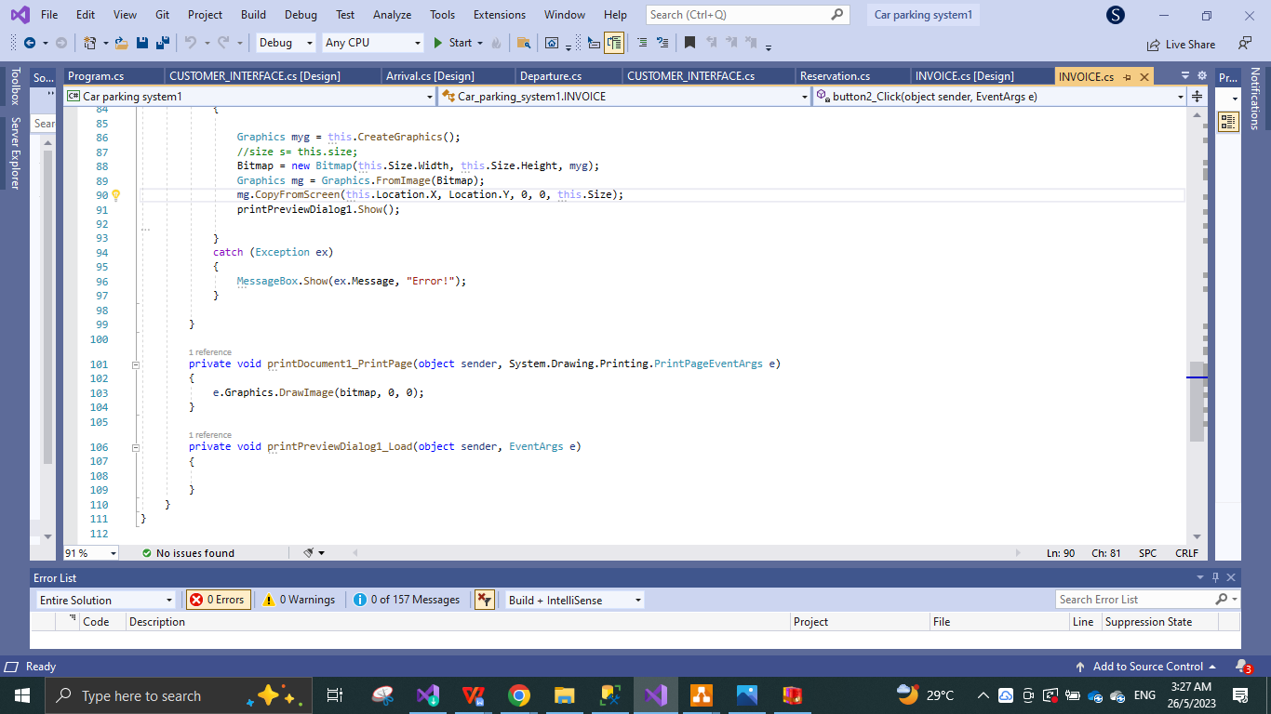

Figure 4.51

* Above are all the code for INVOICE FORM PAGE.

**CUSTOMER WELCOME PAGE AND INTERFACE CODE:**

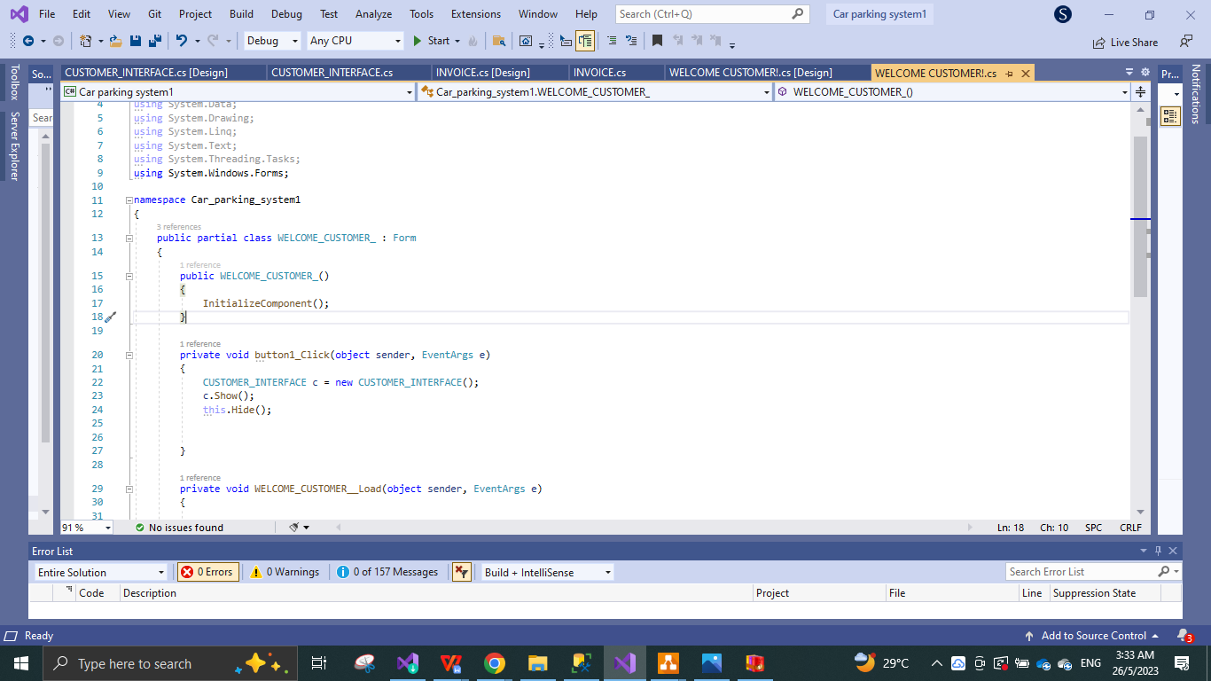

Figure 4.52

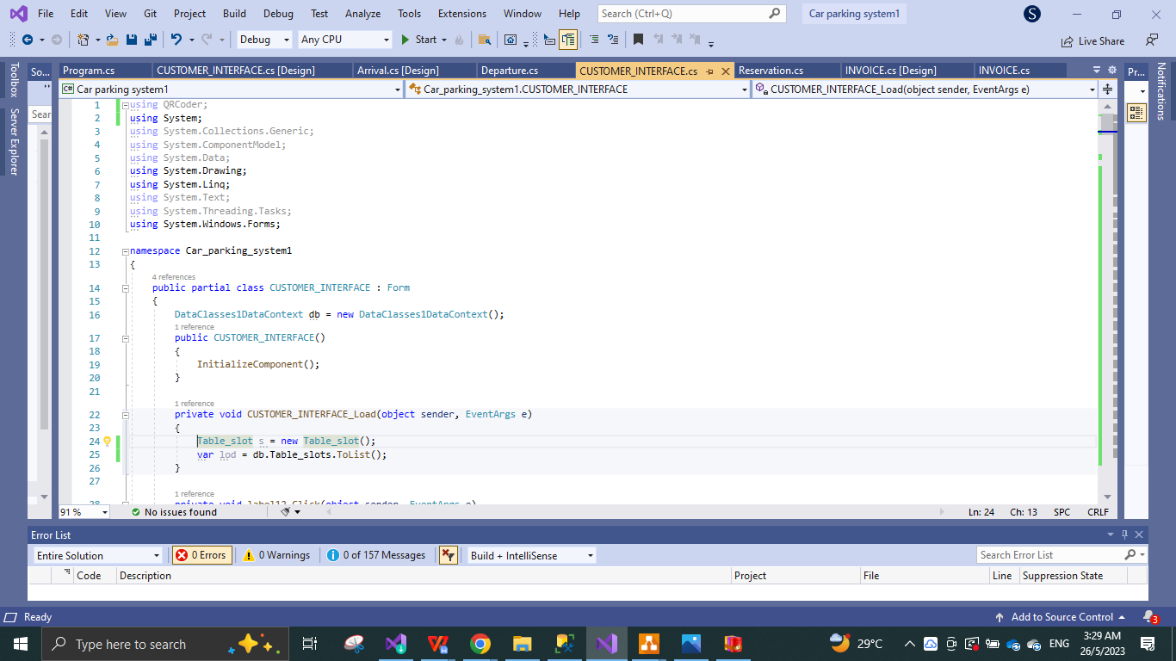

Figure 4.53

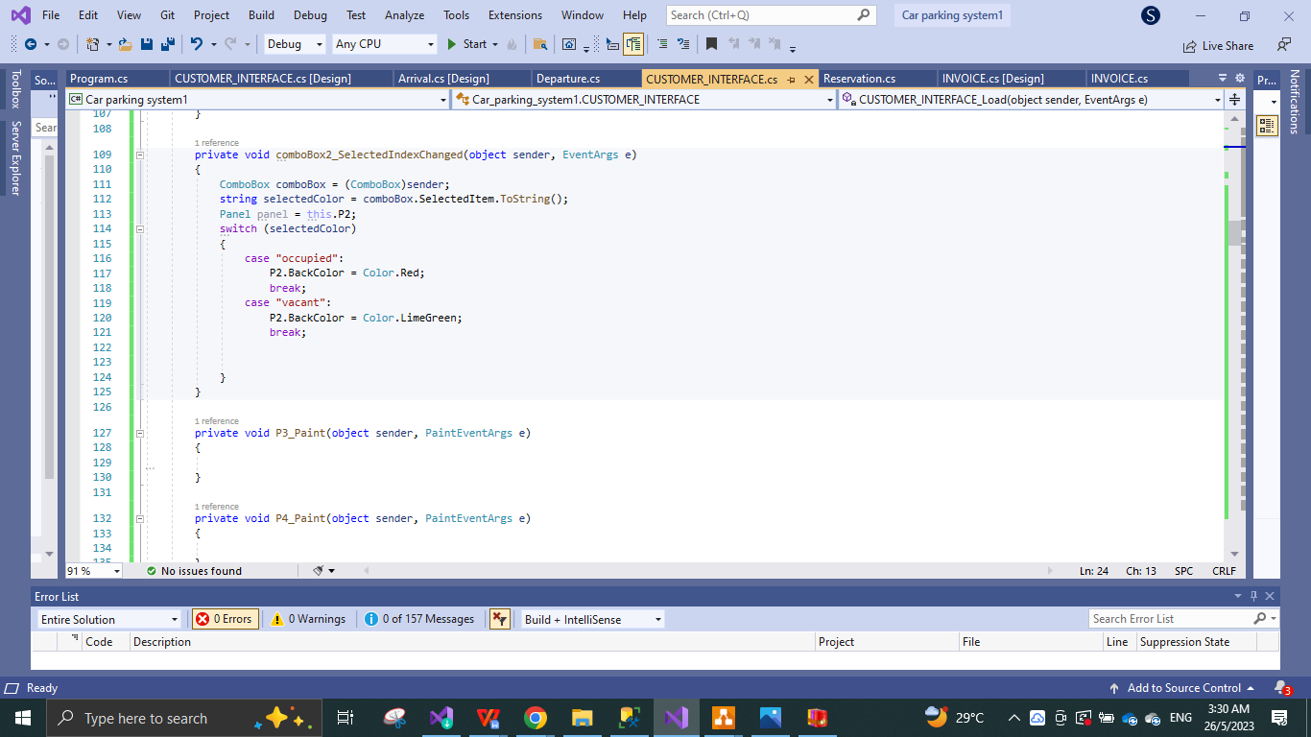

Figure 4.54

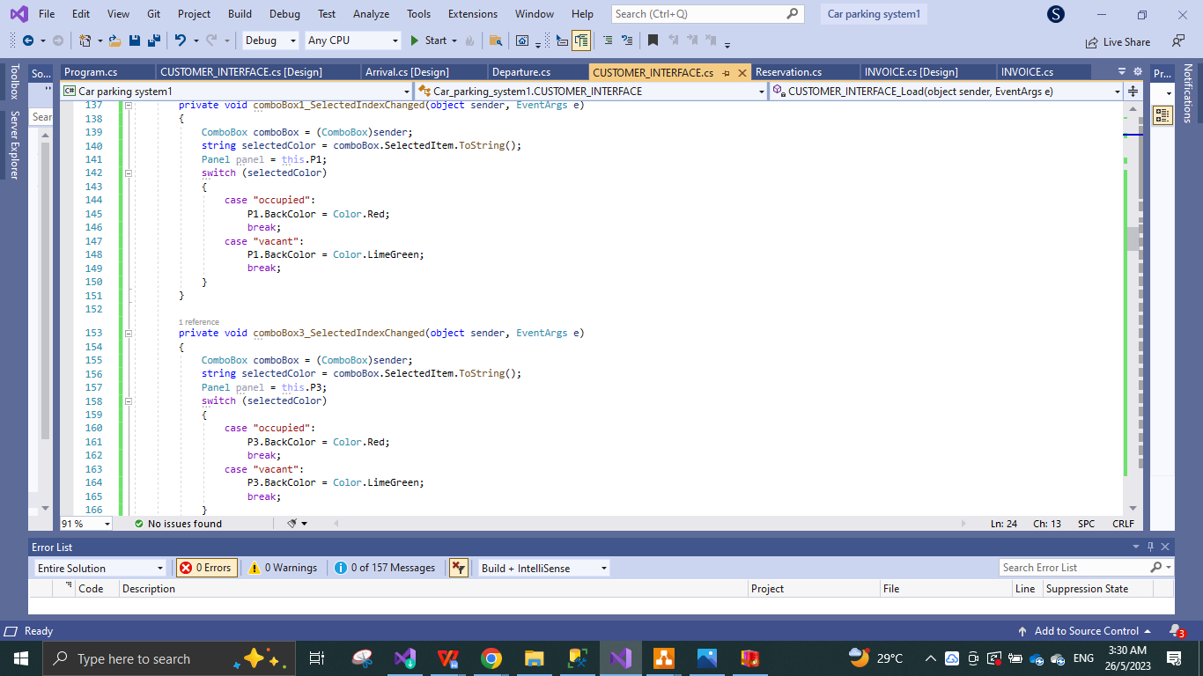

Figure 4.55

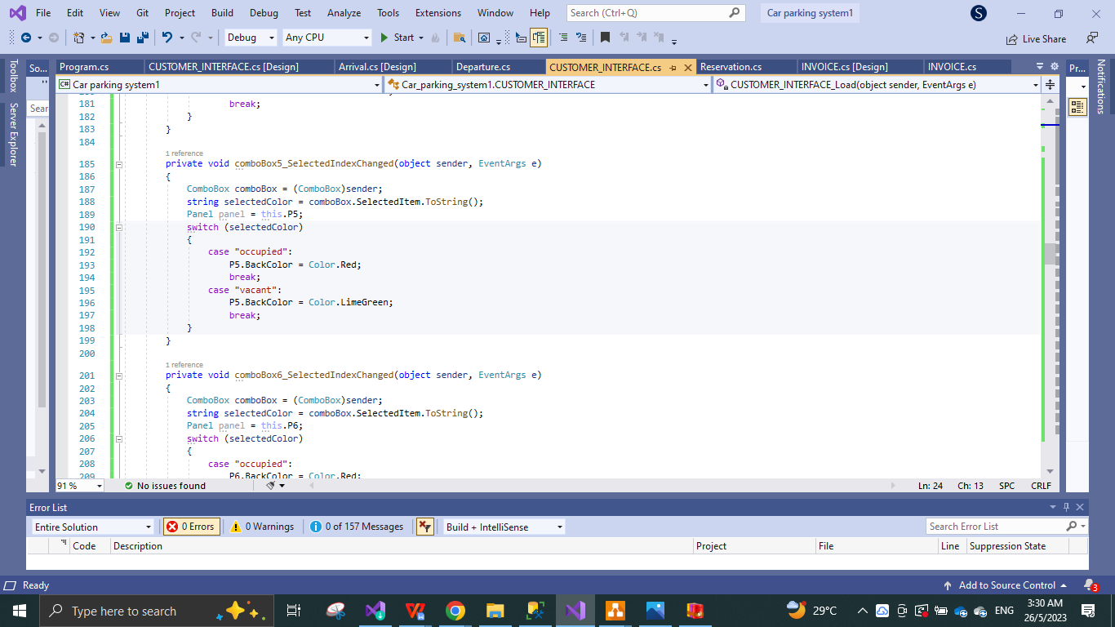

Figure 4.56

* Above are the code for the **CUSTOMER INTERFACE WHICH PROVIDES THE USER WITH SLOT AVALABILITY, SCN CHECK IN AND QR PAY.**

### 4.3 Database implementation

The following images are the database tables, categories and listings in reference to the car parking system including the data inventory stored so far.

**ACCOUNTS TABLE:**

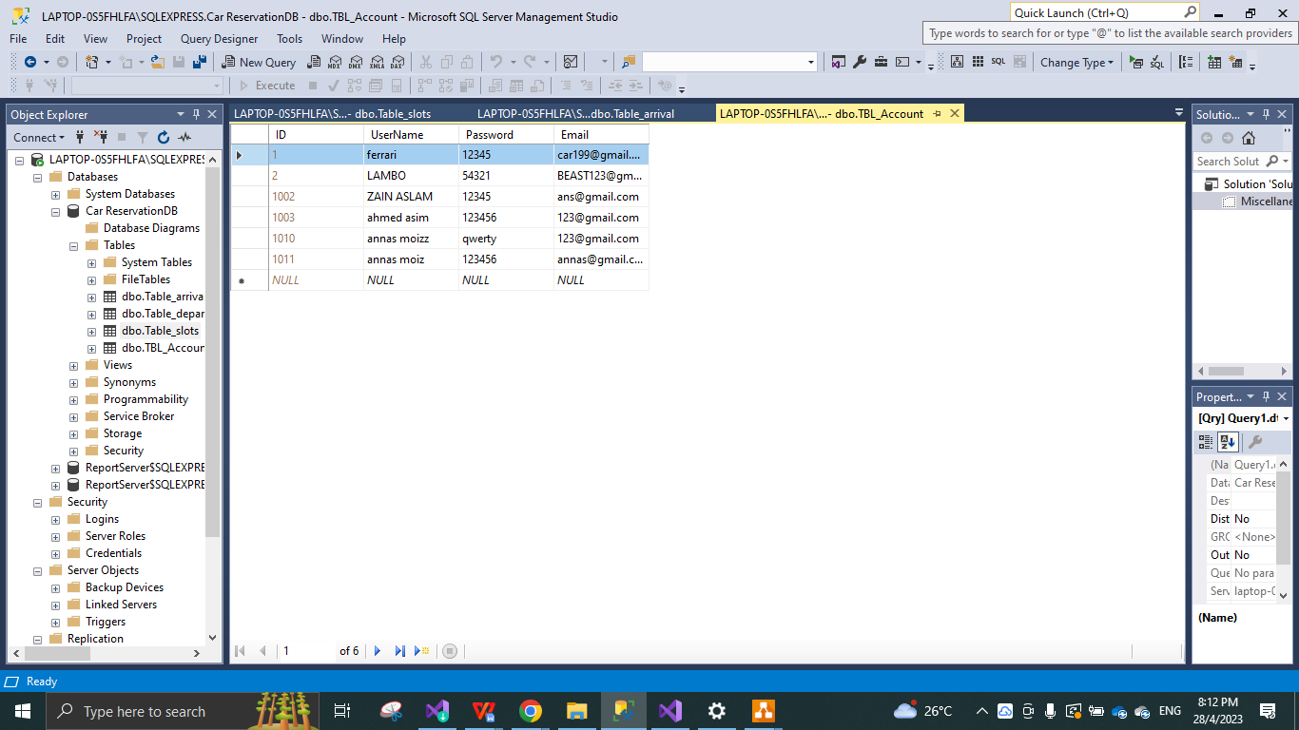

Figure 4.57

* Above image is the ACCOUNTS table consisting of ID, USERNAME, PASSWORD and EMAIL with the data collected.

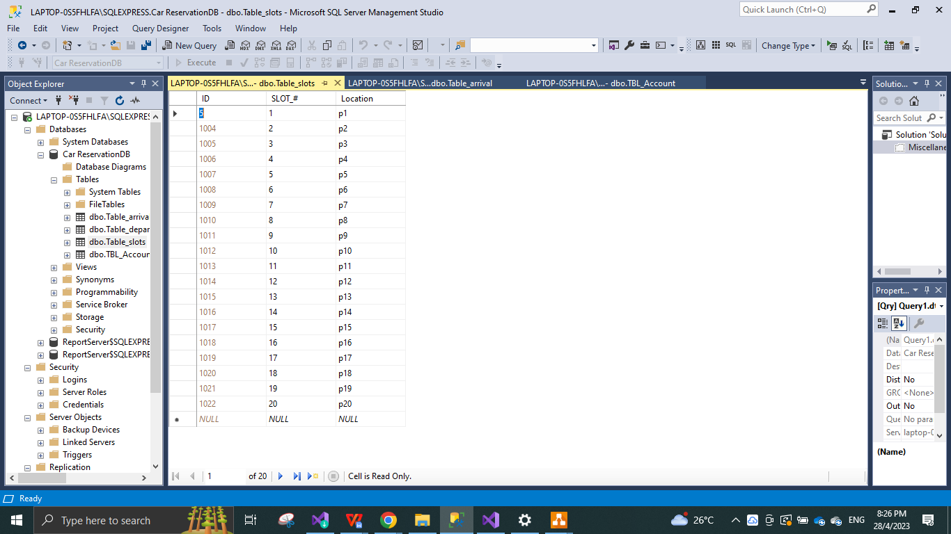

Figure 4.58 **SLOTS TABLE:**

* Above image is the SLOT table consisting of ID, SLOT NUMBER and LOCATION, with the assigned data information.

**ARRIVAL TABLE:**

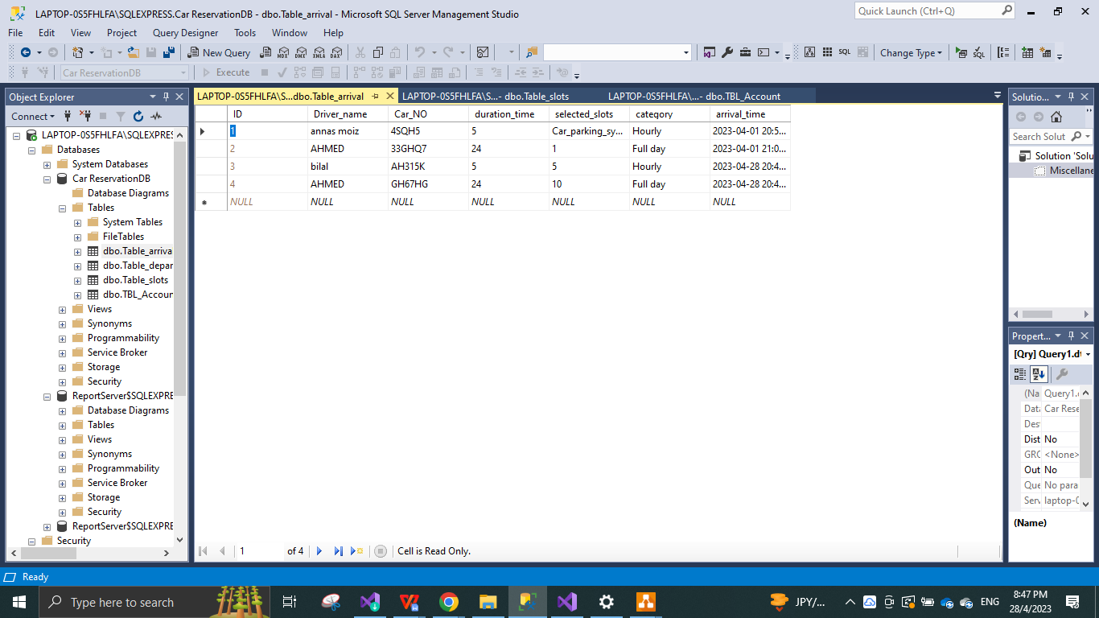

Figure 4.59

* Above image is the ARRIVAL table consisting of ID, DRIVER NAME, CAR NO, STAY TIME, SLOT SELECTED, CATEGORY OF TIME AND ARRIVAL TIME.

**DEPARTURE TABLE:**

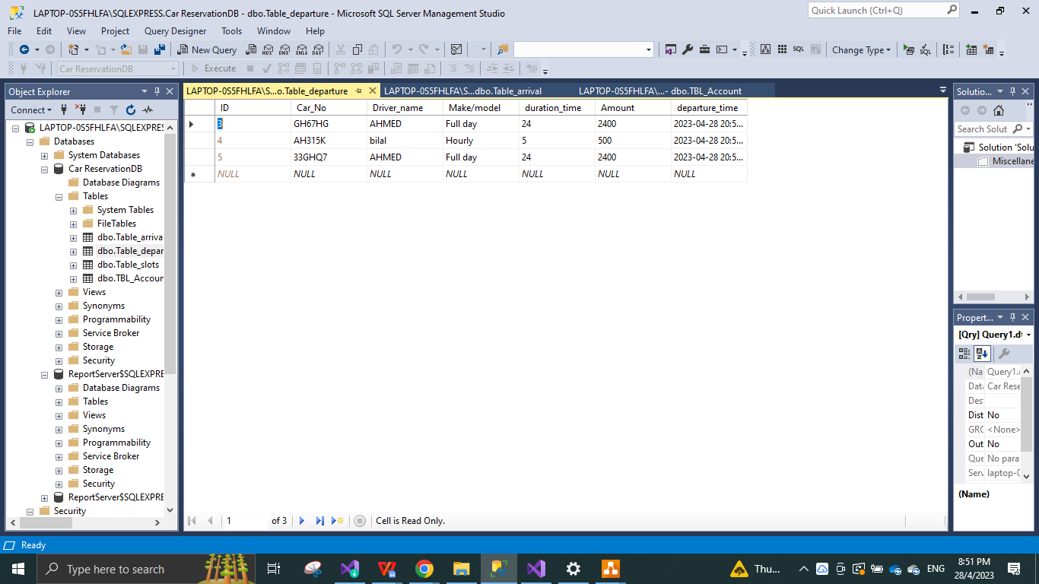

Figure 4.60

* Above image is the database table of the DEPARTURE consisting of ID, CAR NO, DRIVER NAME, MAKE AND MODEL OF THE CAR, DURATION TIME, AMOUNT, AND DEPART TIME.

## 4.4 Test Results

|  |  |  |  |  |
| --- | --- | --- | --- | --- |
| **Test Number** | **Test Name (Testing Item)** | **Purpose of test/Test Procedure** | **Expected Result** | **Result** |
| 1 | Registration test | Send the user onto the login page while collecting username, password and email in database accounts table | Shows message “registered successfully” Takes user to log in page | Passed |
| 2 | LOGIN TEST | User enters username and password in order to view the main welcome page | Takes user to the main welcome page | Passed |
| 3 | Arrival add test | Add arriving car details and click button add | Give message “car parked successfully” | Passed |
| 4 | Arrival edit test | User can select customer and edit by changing the data and clicking the edit button | Would you like o edit? If yes then Gives message “ edit successful” | Passed |
| 5 | Arrival delete test | User can select customers and delete by clicking delete button | User gets message “deleted successfully | Passed |
| 6 | Arrival error test | If wrong input shows error message | User gets message “this specific car already parked”, “box empty please fill details” and “error”. | Passed |
| 7 | Arrival report test | User can print out the grid view report by clicking report button | Print setting pops up, for print type selection.. | Passed |
| 8 | slot add test | Add slot details and click button add | Give message “slot added successfully” | Passed |
| 9 | Slot edit test | User can select customer and edit by changing the data and clicking the edit button | Would you like o edit? If yes then Gives message “ edit successful” | Passed |
| 10 | Slot delete test | User can select customers and delete slot by clicking delete button | User gets message “slot deleted successfully | Passed |
| 11 | Slot error test | If wrong input shows error message | User gets message “this slot already occupied”, “box empty please fill details” and “error”. | Passed |
| 11 | Slot report test | User can print out the grid view report by clicking report button | Print setting pops up, for print type selection.. | Passed |
| 12 | Departure test | Depart car by selecting details and click button depart | Give message “departed successfully” | Passed |
| 13 | Departure edit test | User can select customer and edit by changing the data and clicking the edit button | Would you like o edit? If yes then Gives message “ edit successful” | Passed |
| 14 | Departure delete test | User can select customers and delete by clicking delete button | User gets message “deleted successfully | Passed |
| 15 | Departure error test | If wrong input shows error message | User gets message “this specific car already parked”, “box empty please fill details” and “error”. | Passed |
| 16 | Departure report test | User can print out the grid view report by clicking report button | Print setting pops up, for print type selection.. | Passed |
| 17 | Reservation print test | User can select print button to print out the reservation grid view | Print settings options pop up with print option. | Passed |
| 18 | INVOICE GENERATOR TEST | Admin selects customer to generate his/her invoice by clicking invoice button this take the user to invoice page ready to print invoice | Customer invoice is generated, Select print invoice, Print settings options pop up with print option. | Passed |

Table 3.12

**“Below are the images of the testing result phases for each “type’ of error or success messages and function tests.”**

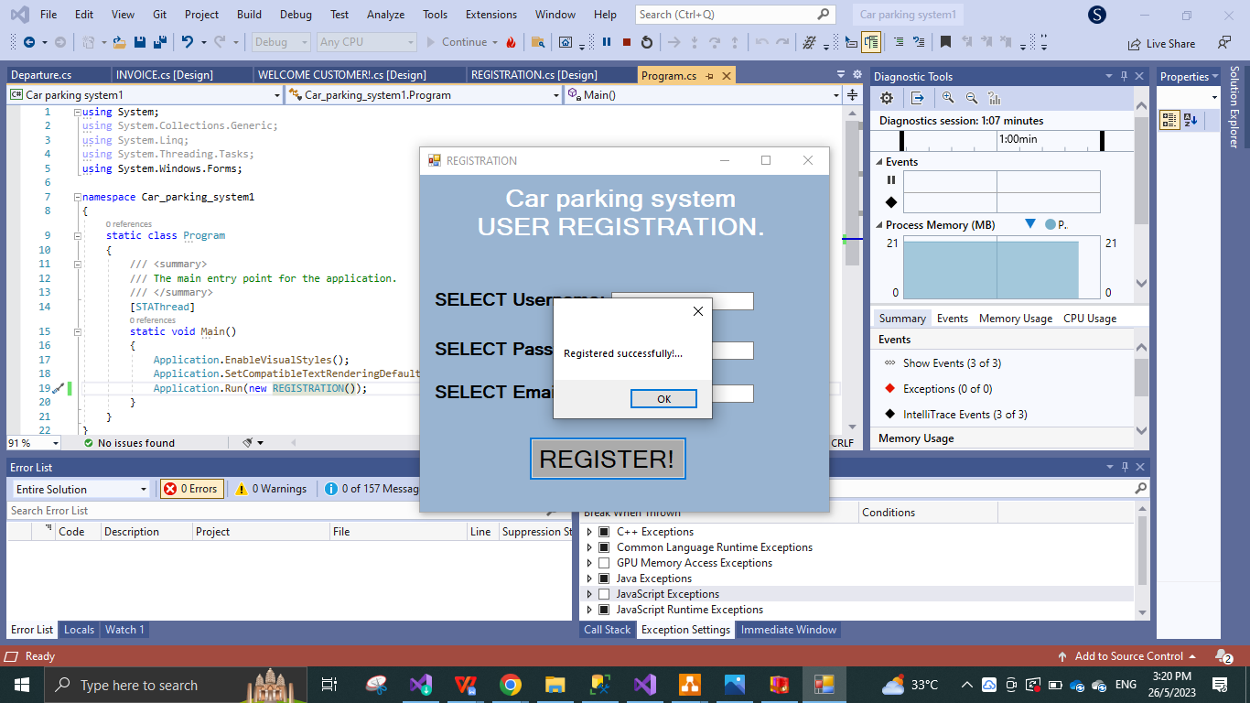

Figure 4.61

* **Test result message show “registered successfully”**

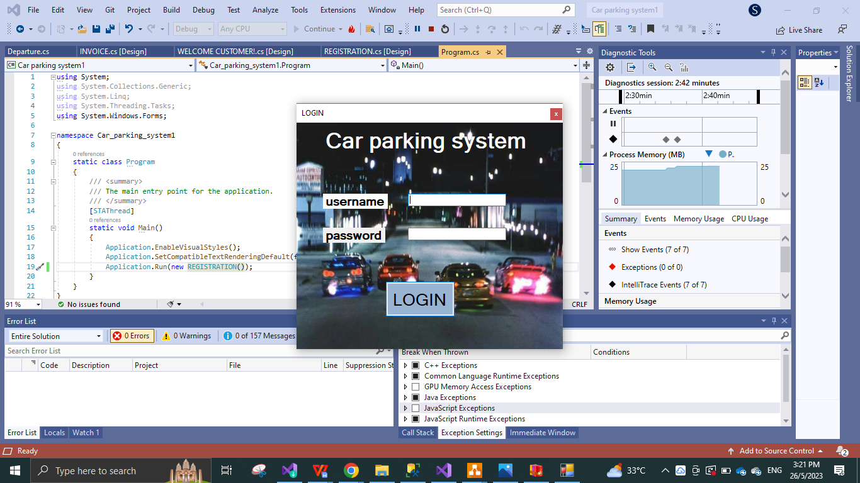

Figure 4.62

* **TEST RESULT SENT TO LOG IN PAGE**

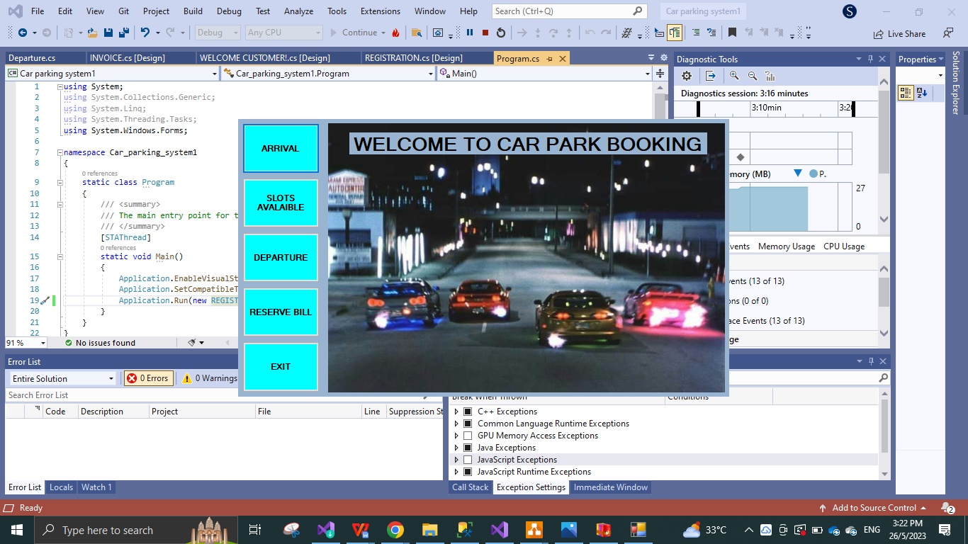

Figure 4.63

* **TEST RESULT AFTER LOGGING IN SENT TO MAIN WELCOME PAGE**

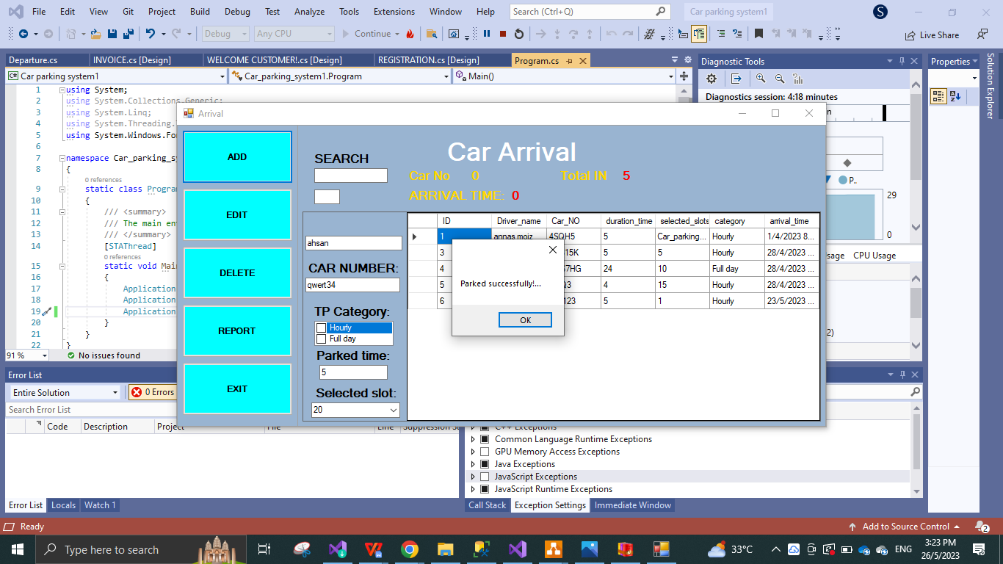

Figure 4.64

* **TEST MESSAGE “ PARKED SUCCESFULY!”**

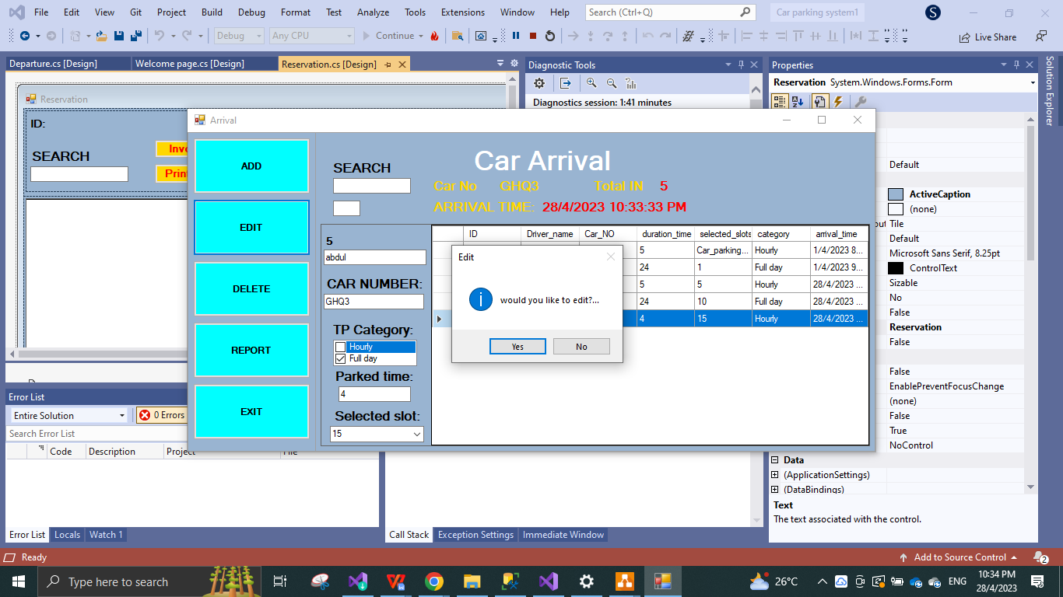

Figure 4.65

* **TEST WOULD YOU LIKE TO EDIT? QUESTION MESSAGE SUCCESS.**

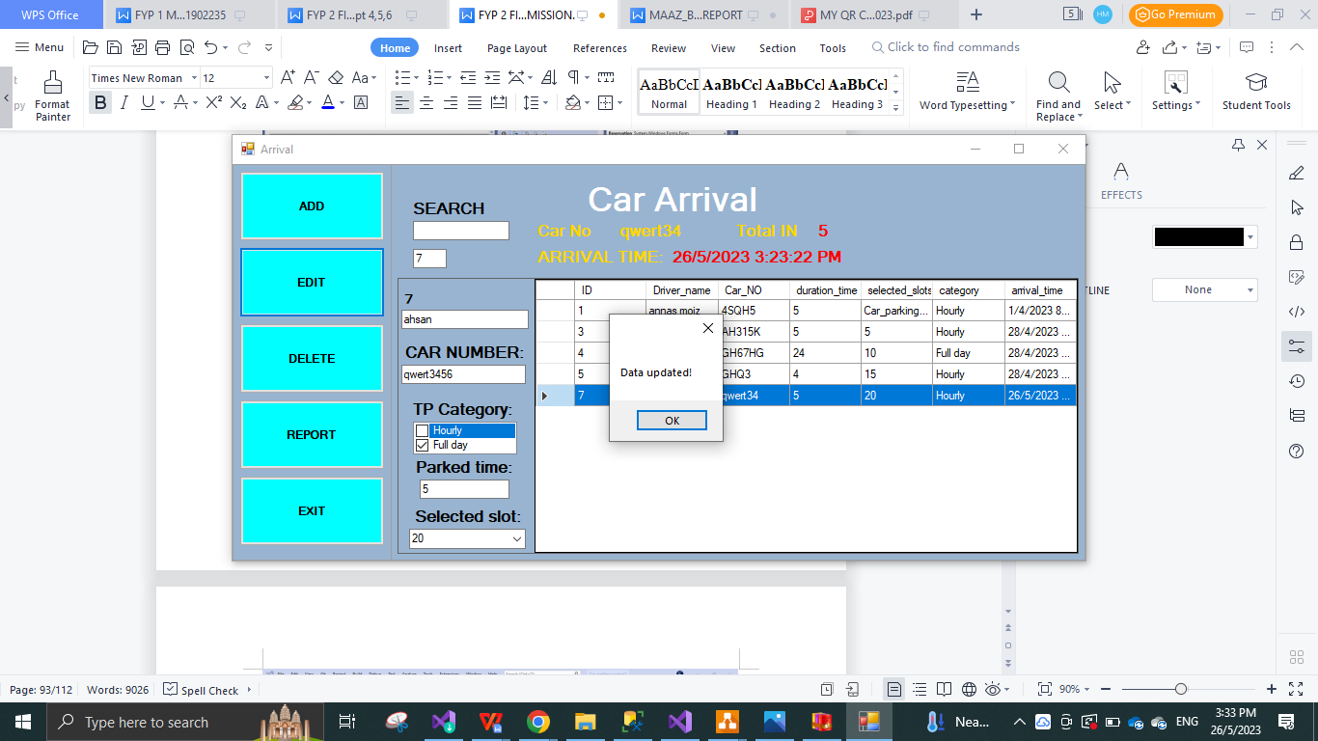

Figure 4.67

* **TEST MESSAGE SHOW “DATA UPDATED”**

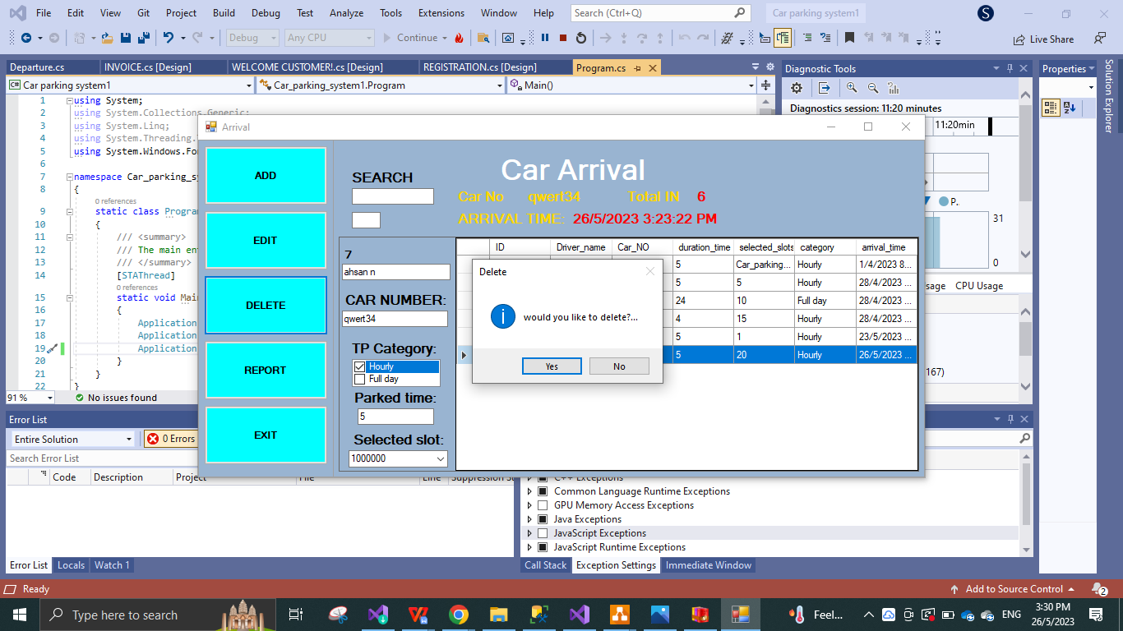

Figure 4.68

* **TEST WOULD YOU LIKE TO DELETE MESSAGE SHOW SUCCESS.**

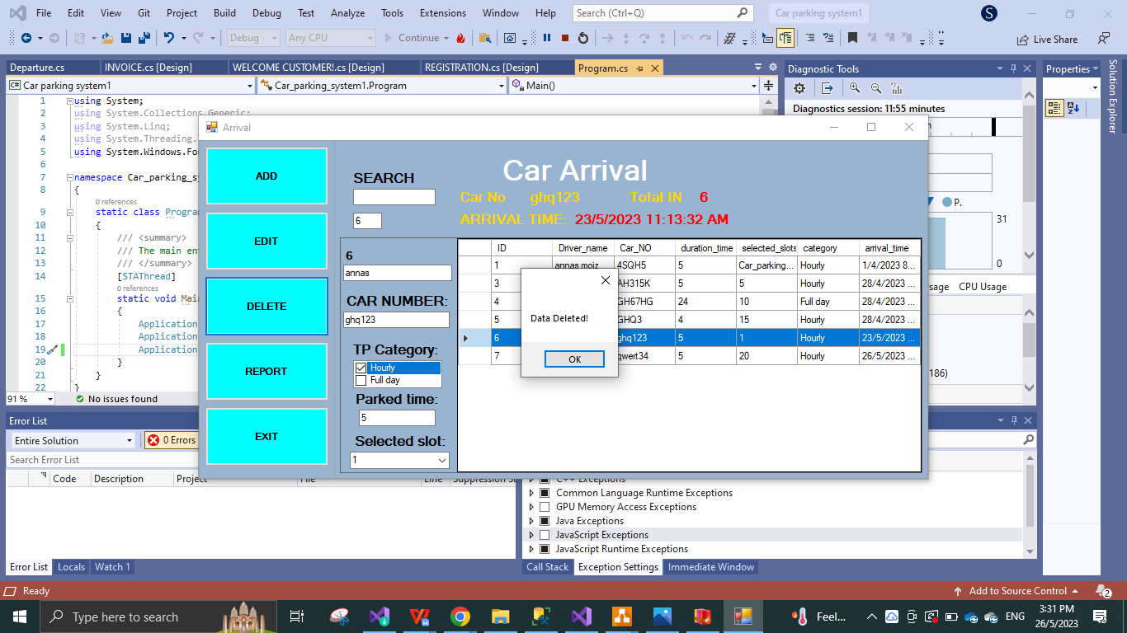

Figure 4.69

* **TEST DATA DELETED MESSAGE SHOW**

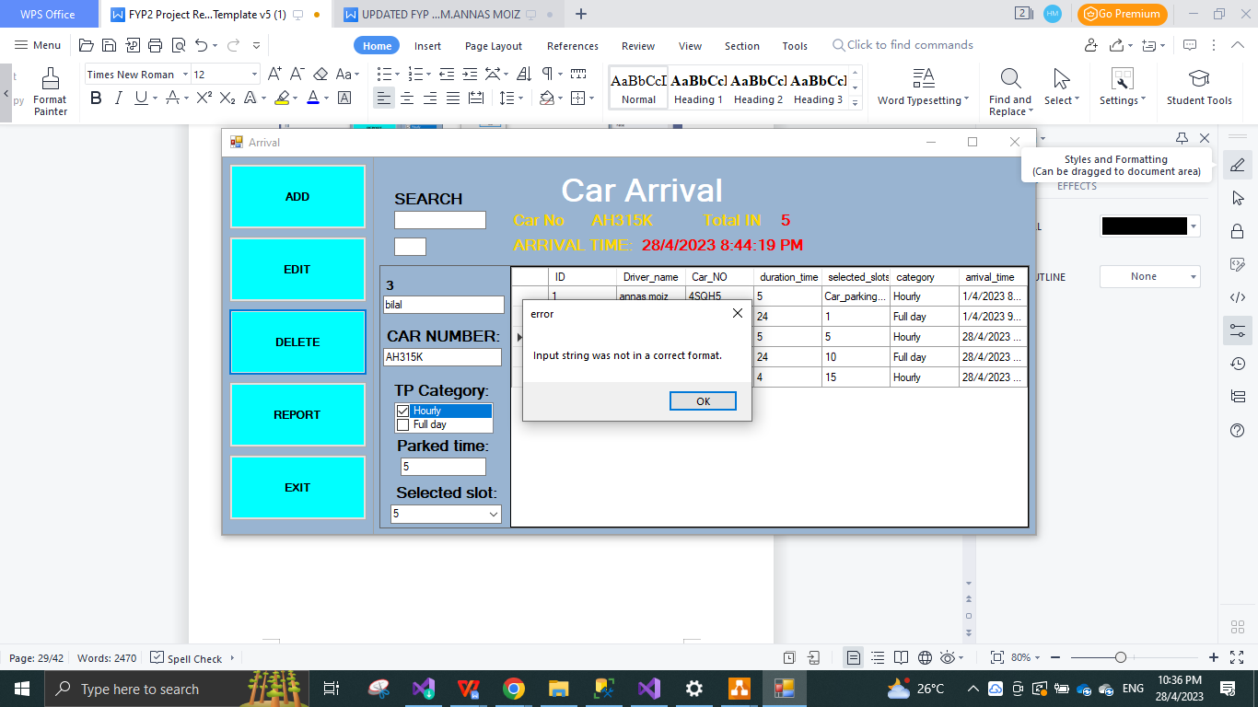

Figure 4.70

* **ERROR TEST PASS, INPUT STRING NOT CORRECT!**

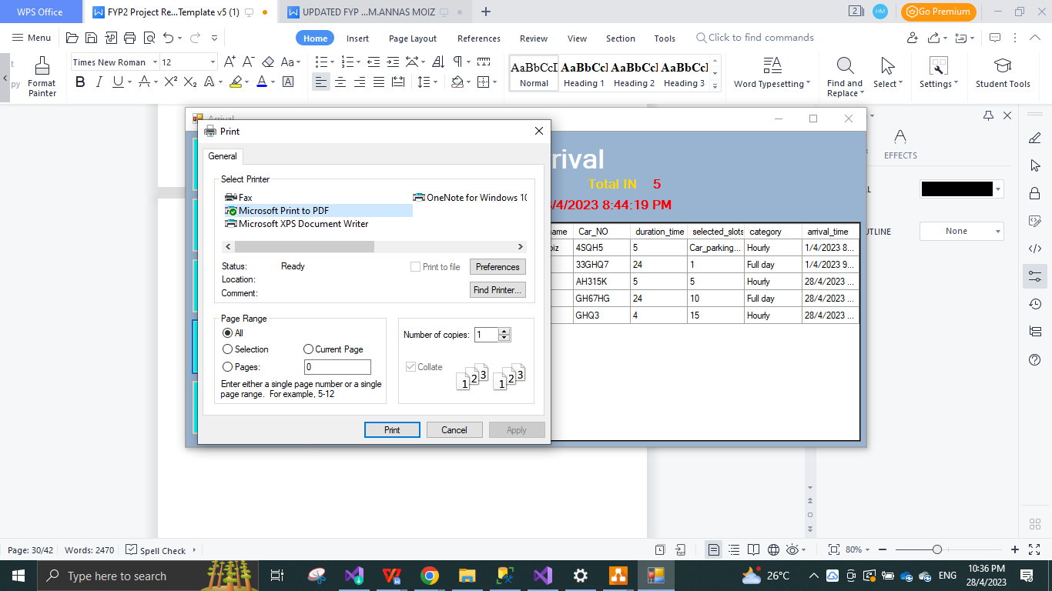

Figure 4.71

* **PRINT OUT TEST! PASS FOR ARRIVAL FORM.**

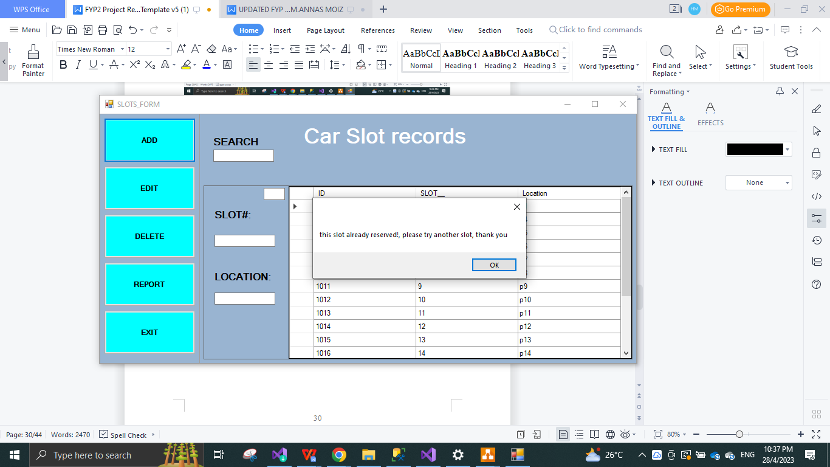

Figure 4.72

* **ERROR MESSAGE SUCCESSS, THIS SLOT IS ALREADY OCCUPIED, PLEASE TRY ANOTHER SLOT, WHEN THE SLOT SELECTED IS ALREADY OCCUPIED THE SYSTEM WILL SUCCESFULLY SHOW THIS MESSAGE.**

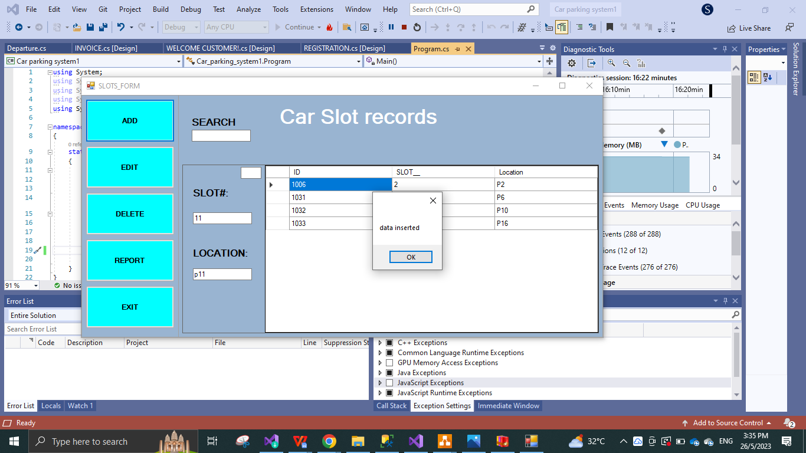

Figure 4.73

* **“DATA INSERTED” MESSAGE SHOW TEST PASS FOR SLOTS FORM**

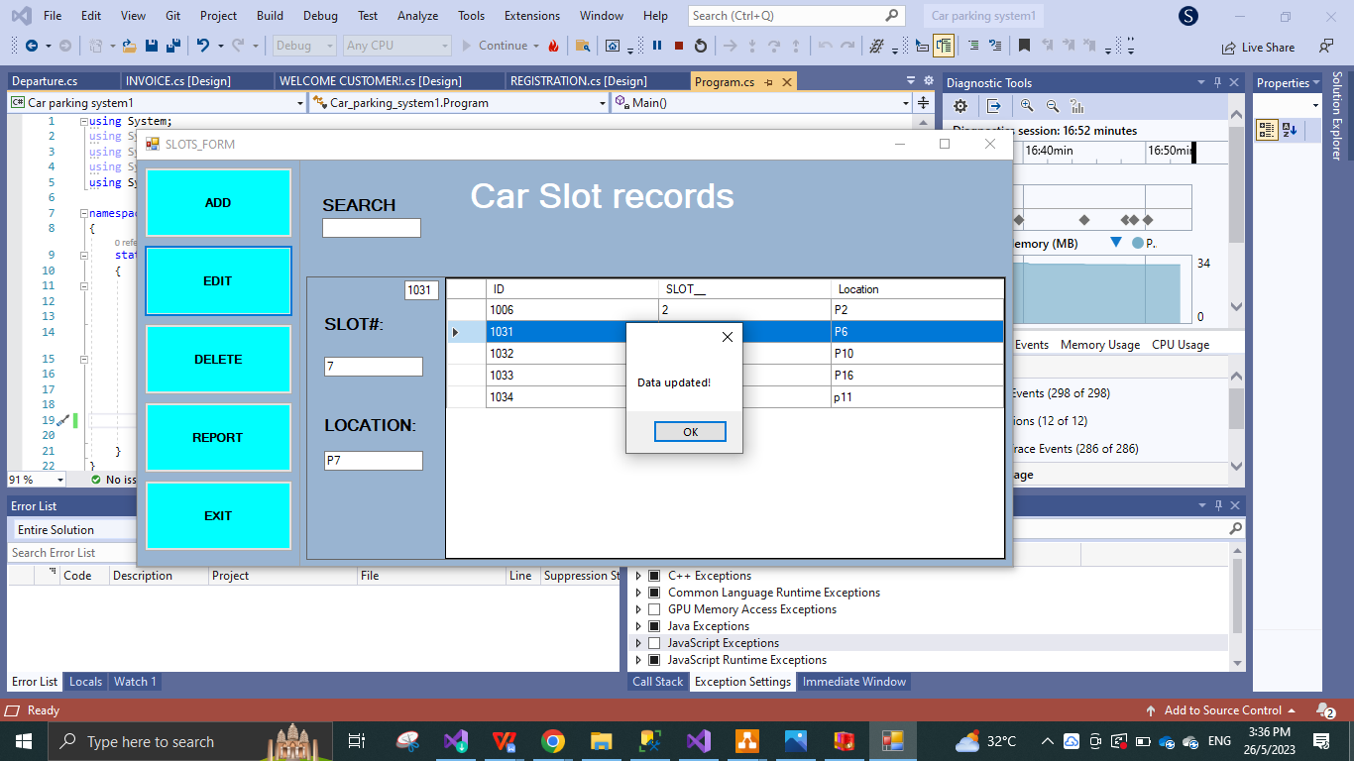

Figure 4.74

* **“DATA UPDATED” MESSAGE SHOW TEST PASS FOR SLOTS FORM.**

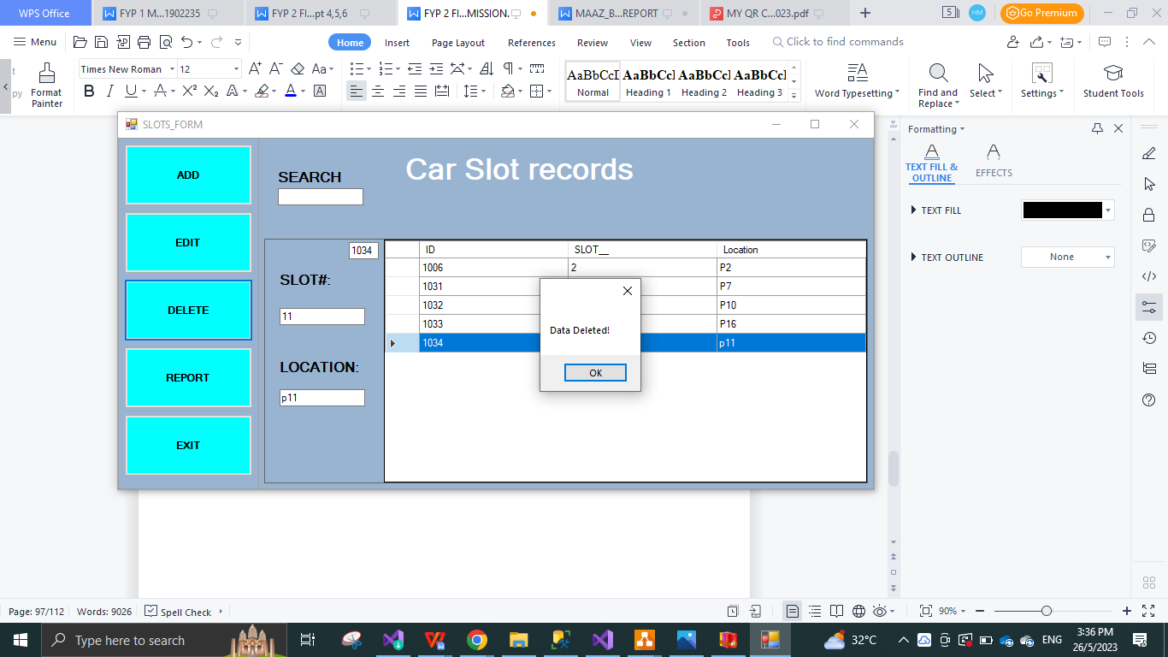

Figure 4.75

* **MESSAGE SHOW “DATA DELETED” FOR SLOTS FORM.**

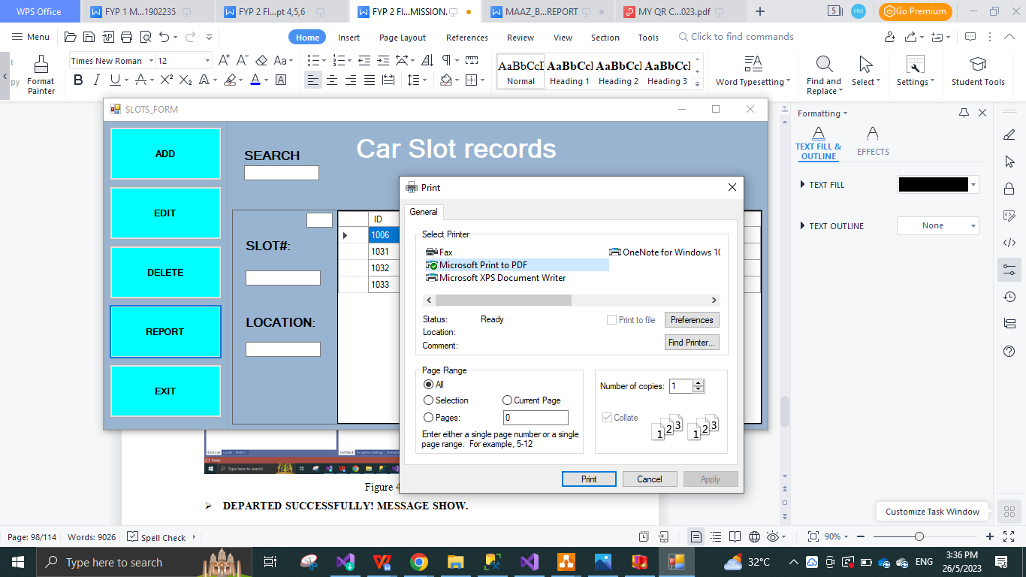

Figure 4.76

* **TEST PASS PRINT OUT FOR SLOTS FORM**

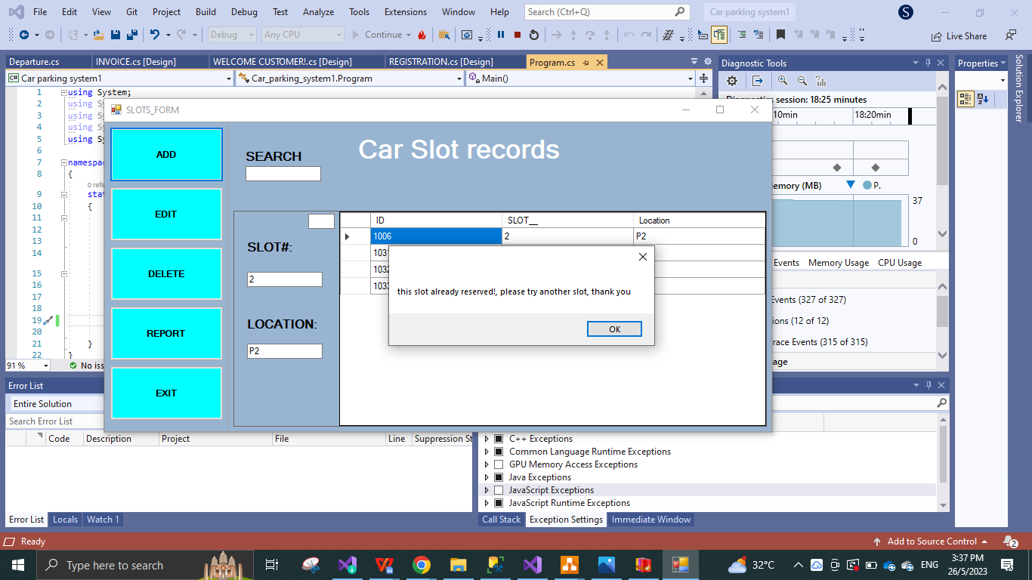

Figure 4.77

* **SLOT ALREADY OCCUPIED MESSAGE SHOW TEST PASS!**

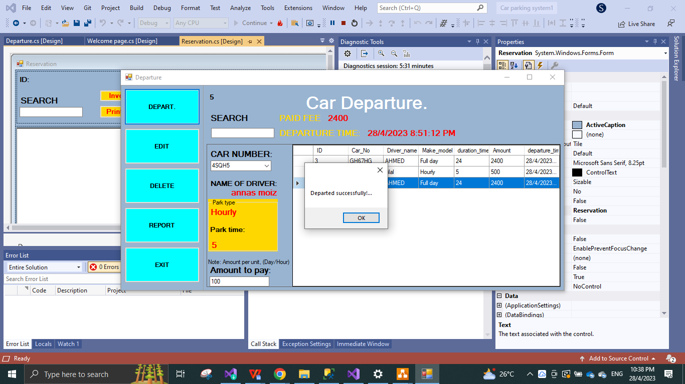

Figure 4.78

* **DEPARTED SUCCESSFULLY! MESSAGE SHOW.**

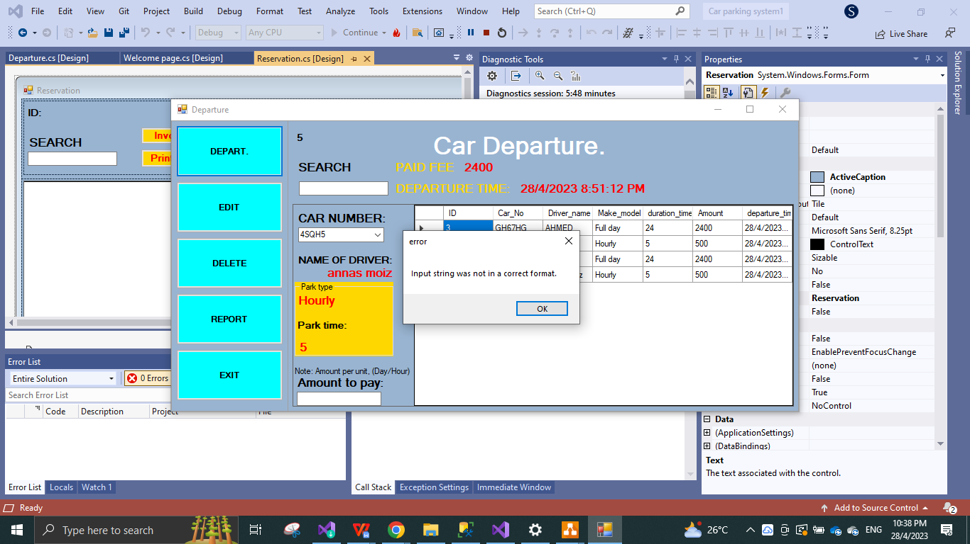

Figure 4.79

* **IF WRONG INPUT FOR EXAMPLE, NO AMOUNT LISTED, SHOW ERROR MESSAGE: INPUT STRING NOT IN CORRECT FORM.**

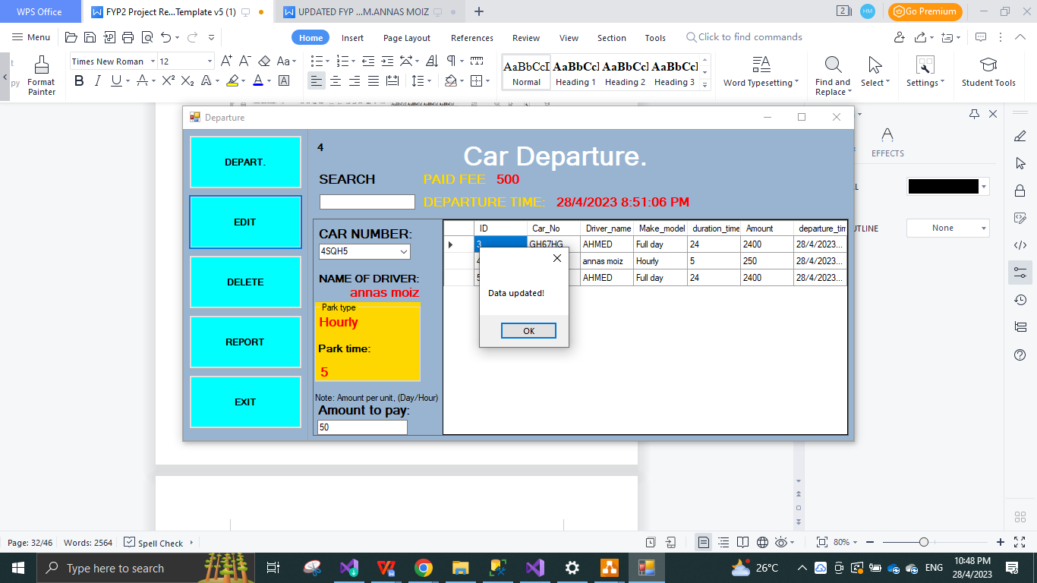

Figure 4.80

* **DATA updated (EDIT) SUCCESFULLY! MESSAGE SHOW.**

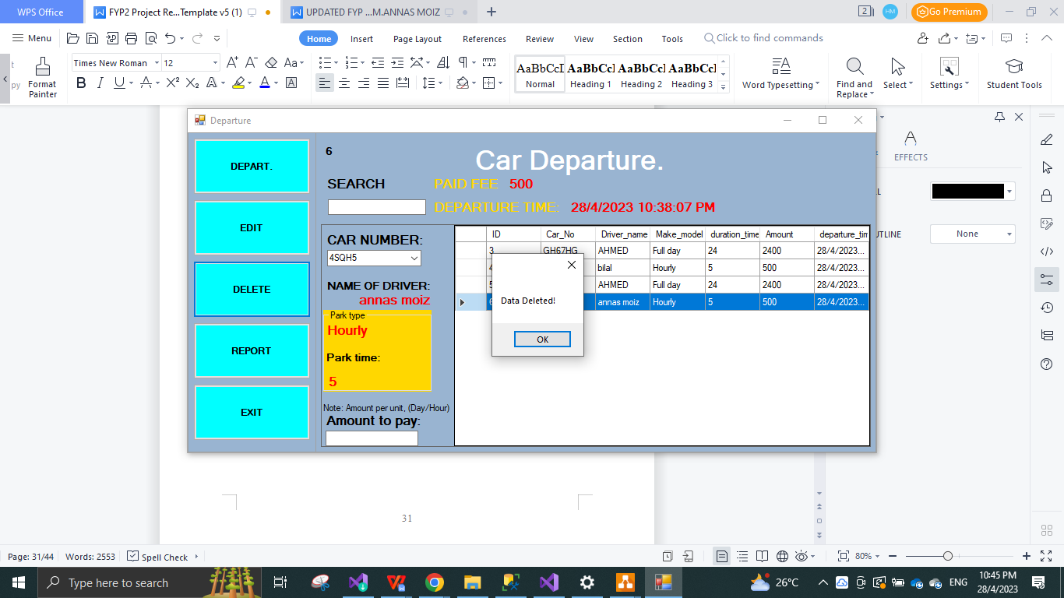Figure 4.81

* **DATA DELETED! MESSAGE SHOW AFTER DELETINGOF THE DATA IS SUCCESSFUL.**

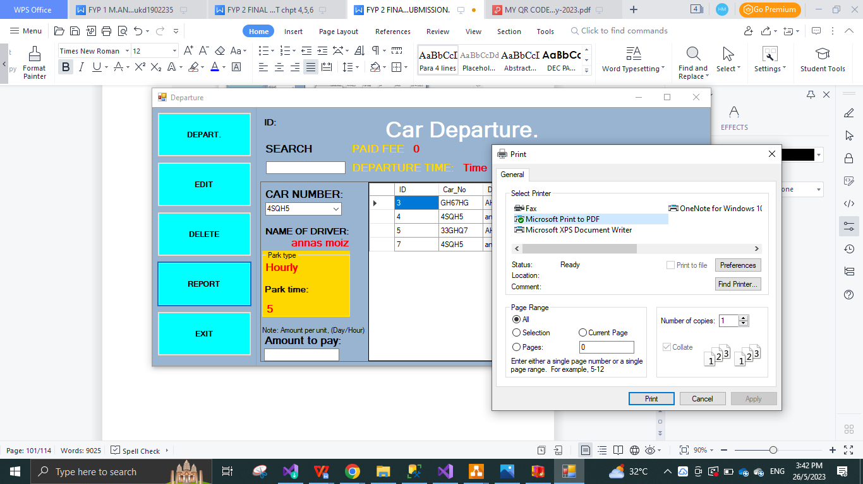Figure 4.82

* **PRINT OUT TEST PASS FOR DEPRTURE FORM**

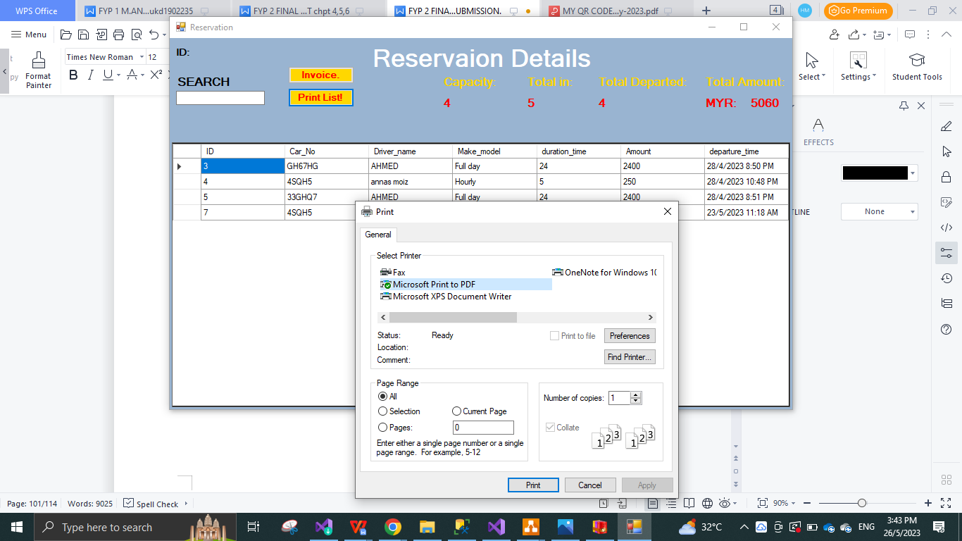Figure 4.83

* **INVOICE GENERATOR PRINT OUT TEST PASS SUCCESFULL**

## 

## 4.5 Chapter Summary

In this Chapter the author has dictated every aspect of the development process such as the framework design, the functions and coding, database and category essentially creating easement of the reader to compile all the data provided with articulate explanation with description and display, furthermore followed by test results to conclude the project successfully working and ready to initiate and commence the system program onto a device.

# CHAPTER 5 RESULTS AND DISCUSSION

## 5.0 Introduction

In this section, author depict the consequence of the carried out framework system application in the wake of testing the system. What's more, the created framework necessities to test by the designer in as per the test plan how the carried out framework is functioning. Notwithstanding, all the element and capabilities are working appropriately and thus testing is an imperative part for the venture. In this segment, the aftereffect of testing technique for this task, assessment of the venture and the future work examined completely.

## 5.1 Results of the Project

The result of the project have been very promising and took a lot of testing and configuration in order to be deemed a success, the system went through rigorous testing of each form and button selection that should do a certain task or display a certain message.

once the user has registered using the details the data is collected in the database accounts, and the user is ready to log in, otherwise an error message is successfully displayed.

Moving onto login page the user types in the username and password which brings the user in the welcome page otherwise successfully displays an error message.

Once in the welcome page the user has the option to select from 5 buttons (arrival, slots form, departure, reserve bill and exit) all these buttons are coded to link each one to its appropriate destination which has been successfully tested.

In the arrival form the user can add edit and delete with the availability to print out the data while the arriving customer data successfully displaying error message if the input string is not correct

Furthermore, in the slot form shows the available slots and the option to add edit and delete the slots, which are relayed with location category and id category which successfully display an error message if the input key is incorrect

Following to departure which is quite similar to the arrival page and successfully displays the correct error message according to the type of error generated, it can depart the car, edit the input and delete the data with the availability to print out the data.

Once the user needs to take out the complete reservation of the bill in the reserve bill form for the departure amount clearance, he user can select the client which will successfully display all the details such as the capacity, total IN, total departed and the total amount to collect which can be printed out with the help of the print button, further more after selecting a specific client user can successfully generate the invoice with all the credentials with the help of the invoice button.

Finally the option to EXIT which takes the user back to the login page awaiting to successfully work again this ends the user attributes,

User interface is opened up with a welcome message for the customer and a single button stating pick slot, which upon selection takes the customer to the main customer lobby where the customer can select the slot according and pa online using DIY option of scanning the QR code from the main customer interface.

Furthermore, final testing should be in commence as the system is ready and need to work in the proper computer at a proper parking lot for further analysis

## 5.2 Evaluation of the system

in order to implement on this project learning c sharp was vital, and having more than basic sense of development was necessary. it was a slow start however it progressed to many advantages moving forward. This project took a lot of planning and research as well as testing and a lot of management to fit the HCI need of the user as well as the client. The system s working accordingly and can by applied to a real project with confidence.

## 5.3 Evaluation of the development Process

The system took a lot of planning and creation of UI/UX design in order to have a pattern out to follow after coming up with the flowchart as shown in (figure 1.1) the project started to commence, and implementation began, with progress and addition of functions and codes with the help and guidance of the supervisor, the system was taking form ready to be tested, furthermore after many test and further development, such as user interface page to select slots and QR code availability for the easement of the client. Project was managed efficiently and with risk analysis. And The system is now now ready to report and analyze in order to work as intended.

## 5.4 Chapter Summary

In this chapter evaluation and description of all the tests concerning the system and the results provided were described and briefed for the reader easement, this chapter dictates how the system works, and all the otherwise results that are required for the system to perform, author also dictates the process of the development and critical analysis on the advancement of the system as well.

# CHAPTER 6 CONCLUSION AND RECOMMENDATIONS

## 6.0 Introduction

This chapter is important since it gives an overall significance of the study. In this chapter author dictates the Stresses the findings upon which a conclusion or conclusions are drawn in line with the objectives set, acknowledges the limitations and suggests further research and recommendations which may be usefully carried out on the topic.

## 6.1 Project Result and Achievement

The system is working successfully without any reinstatement required which might objectify the process of the system, the system has achieved to clock in an arriving car, depart it as well all the while collecting data accurately and efficiently performing all its task. The system maintains stability while faced with testing and shows correct error messages for the easement and clearance for the user.

## 6.2 Advantages of the Application/Website/System

This system can be used for any type for car park available and can begin as a business, weather it be a school, university, hospital or office. This system is ready to be uploaded and linked to the hardware and start the process with little to no adjustment provided, this system can earn passive money as source of income for the user to dictate. This system can provide easier HCI where it uses QR scanning to upload client data, while guiding the client with the map and slots available of the said car park.

## 6.3 Recommendation for Future Enhancement

Well for further development I think the system requires more option of keying in the customer data for the easement of the customer/client, so an NFC tag installation to the customer interface can provide with that task, as with a single tap the user can be able to enter and clock in the car park. And accumulate the amount he has to pay and be able to pay the amount online with ease and comfort and less interaction as taking COVID into consideration.

Furthermore after field testing, patent development is required on the system and as a business plan I would like to motivate my university to consider this system to be used in their new car park where, an hourly charge can be up-to 2 RM, where I would like to ask the profit margin of 50 cents on the dollar as a means to dividends as being the patent holder.

## 6.4 Conclusion

In conclusion the car parking system has fulfilled all of its objectives and criteria, in the field of system development, and development and research as well, this is a prototype system for now however in near future plans to develop into a well recognized application with more features and a better interface as well as the system, The system diffidently has potential to progress even further.

REFERENCES

ORIGINAL system REPORT = RASA ASLI.

**https://revisesociology.com/2017/11/26/the-steps-of-quantitative-research/**

Appendix C

Appendix D